|  |  |
| --- | --- |
| Project- | KredSafe |
| Automation QA | Nilesh Shekdar |
| Tool | TestRigor |

**TestRigor**

TestRigor-

TestRigor is a no-code AI-based test automation tool that allows users to create and maintain test cases using plain English instructions. It’s designed for QA teams, business users, and non-technical testers to automate end-to-end tests with minimal effort.

TestRigor is designed for-

1. QA Engineers

2. Manual Testers

3. Business Analysts

4. Developers

TestRigor Objective-

No coding or selector maintenance. Business users or manual testers can write full end-to-end tests in English, and the platform handles locator strategy, waits, and test reliability automatically.

Key Features

* **Plain-English Test Writing**: Write test cases in natural language—no code, XPath, or CSS needed.
* **Cross-Platform Support**: Works across web, mobile (native/hybrid), desktop, API, email, SMS, 2FA, etc.
* **Self-Healing Tests**: High stability; minor UI changes don’t break tests.
* **CI/CD Integration**: Seamlessly fits into modern DevOps workflows.
* **AI-Assisted**: AI helps generate and maintain tests with minimal manual effort.

Why TestRigor Is Gaining Popularity-

* **AI-Powered Testing**: Tackles bottlenecks like flaky tests and script maintenance using natural language and AI.
* **Non-Technical Accessibility**: Empowers manual testers and non-developers to write automation tests.
* **High Stability**: End-user-level test design reduces breakage from UI changes.

Setting Up TestRigor: Step-by-Step Guide-

• Visit **testrigor.com**

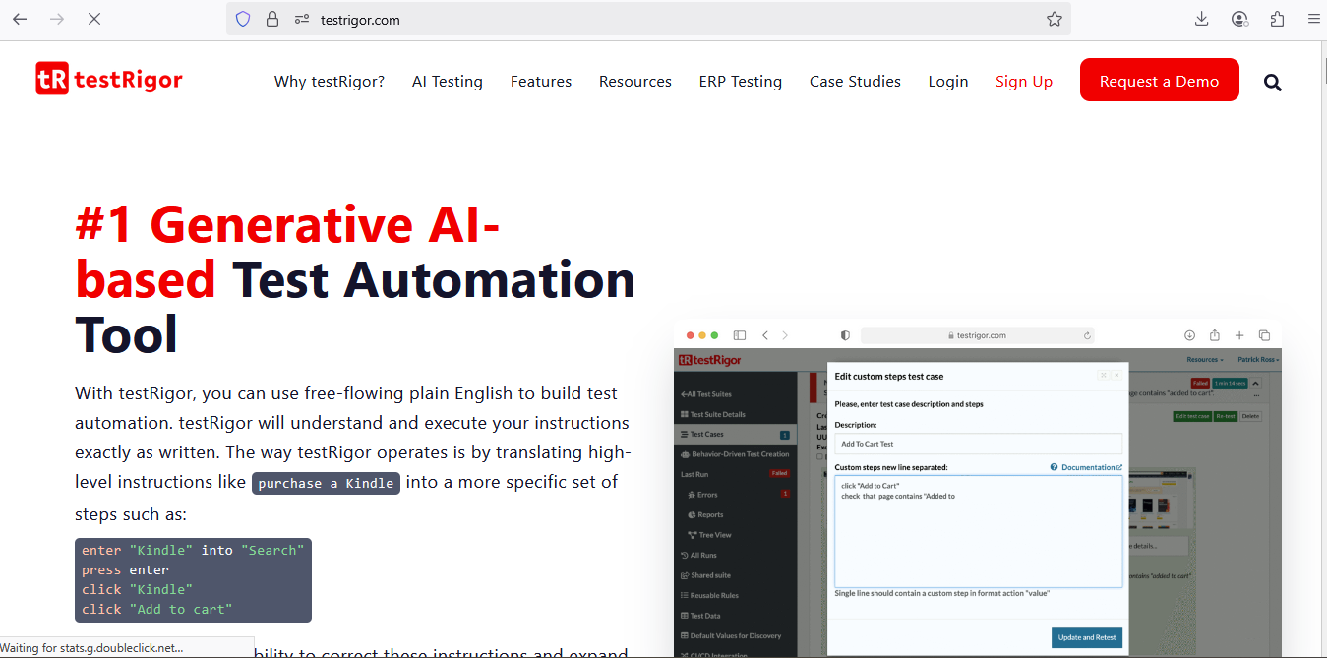

TestRigor is paid Tool.

• Sign up for an account (free trial available)

Signup for 14 –days Free Trail

<https://testrigor.com/sign-up/>

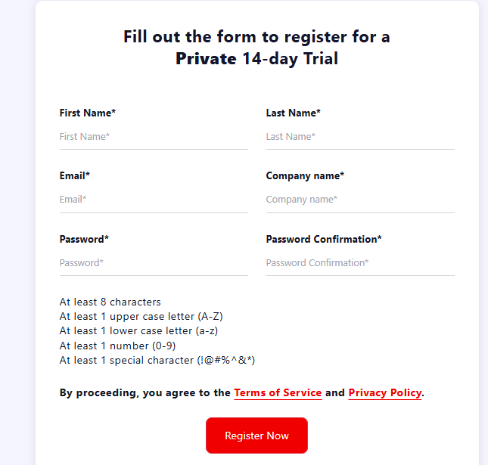

• optionally integrate with SSO (e.g., Google, Okta)

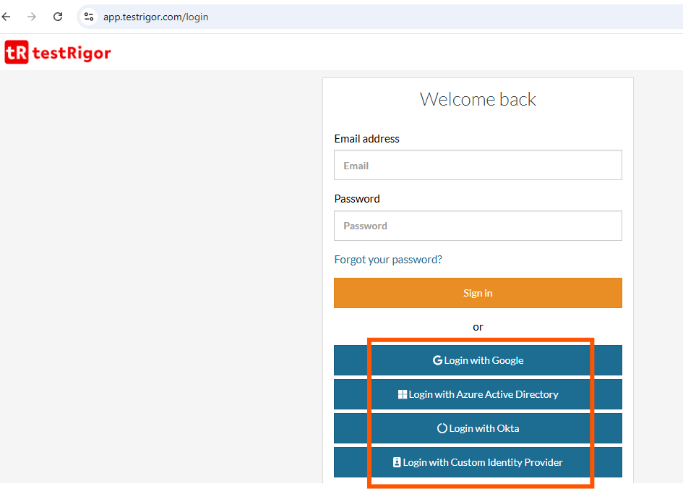

Create a New Test Suite-

After signup or login with google below screen will loaded

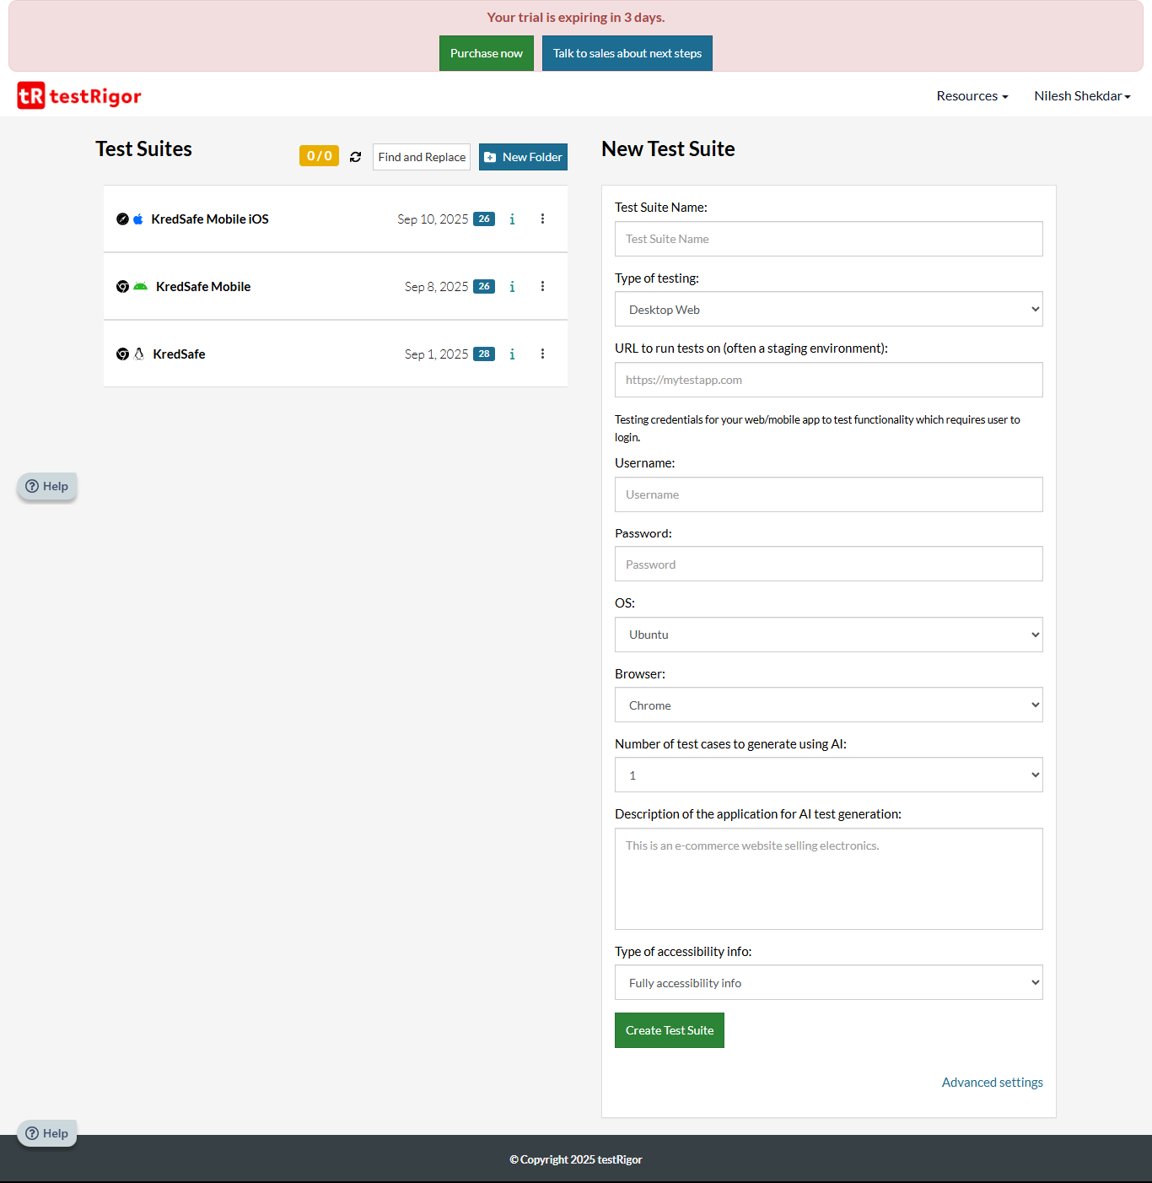

Advanced Setting-

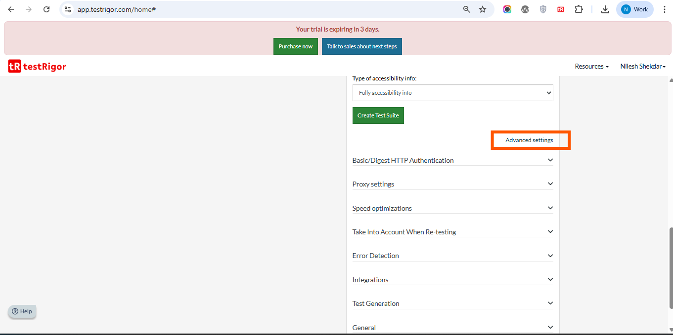

Let create new test Suite .Fill all entries and click on Create Test Suite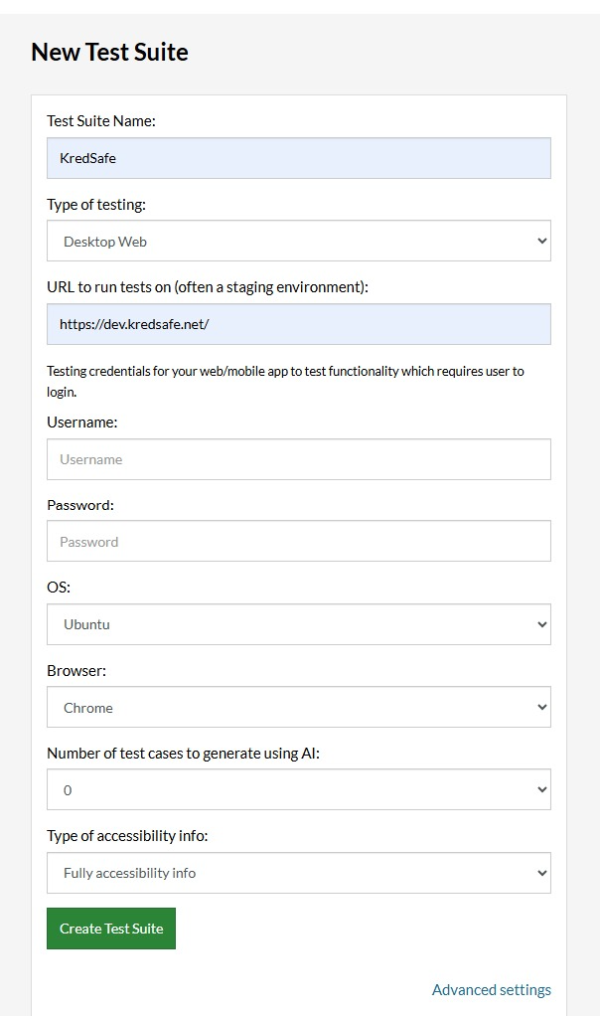

Select Testing Types –

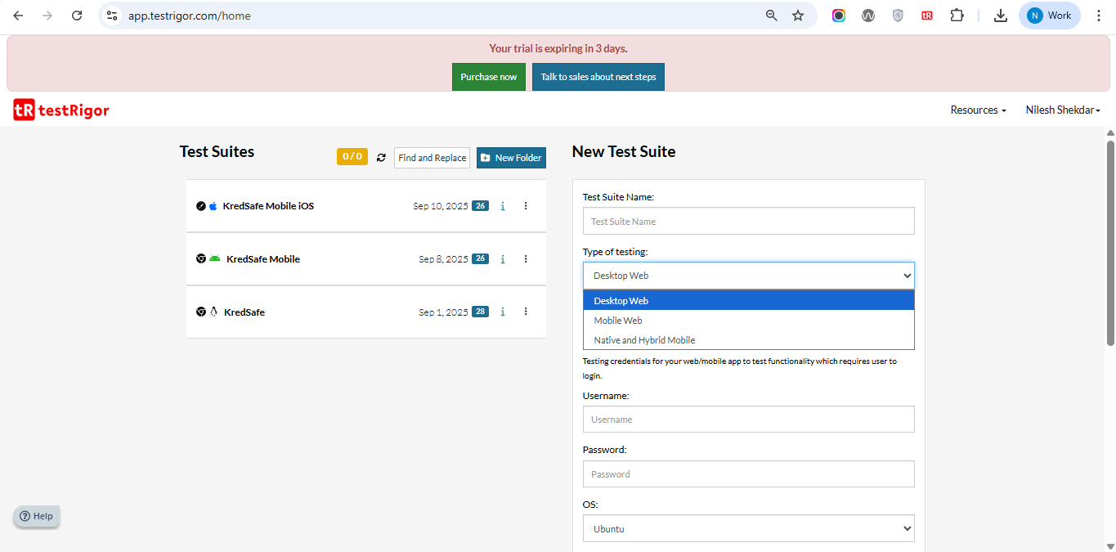

Select Device –

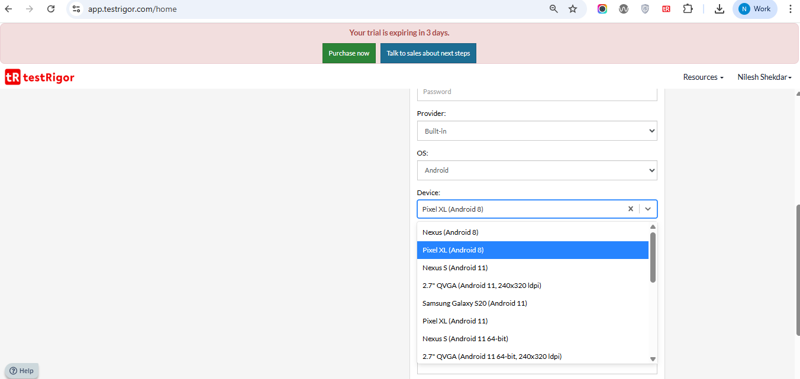

Select OS-

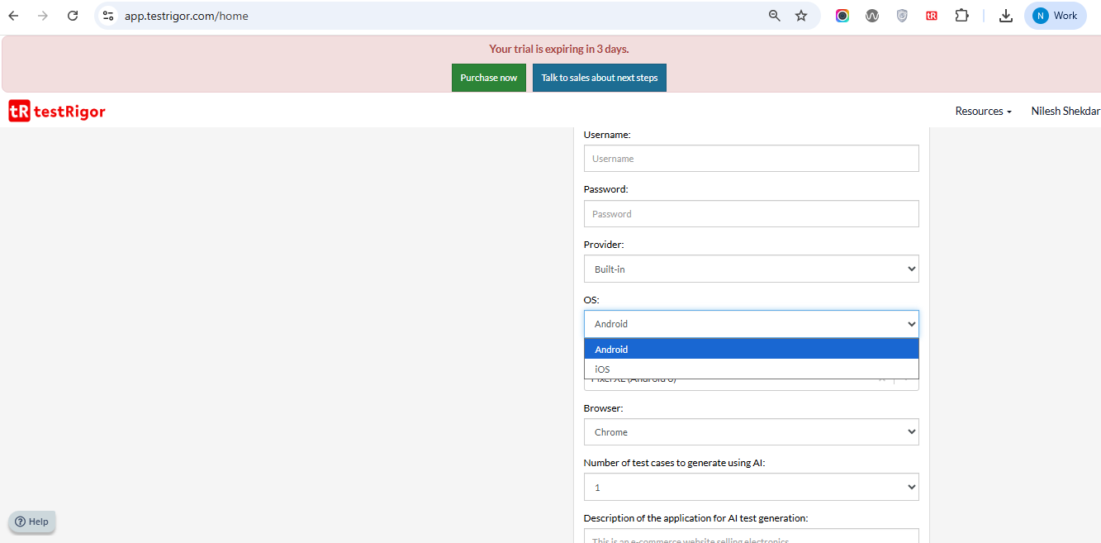

Create First Test Case-

Click on Add Test Case

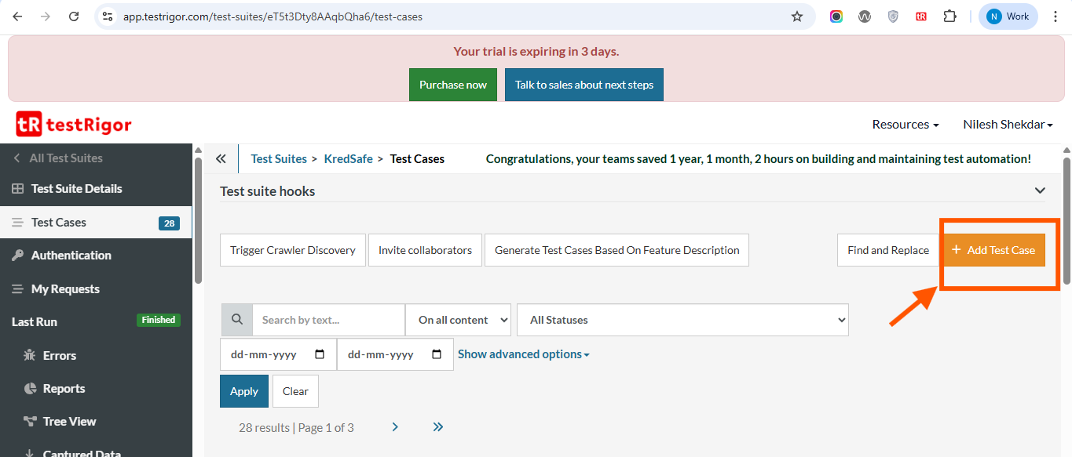

Write simple script in English for Login functionality

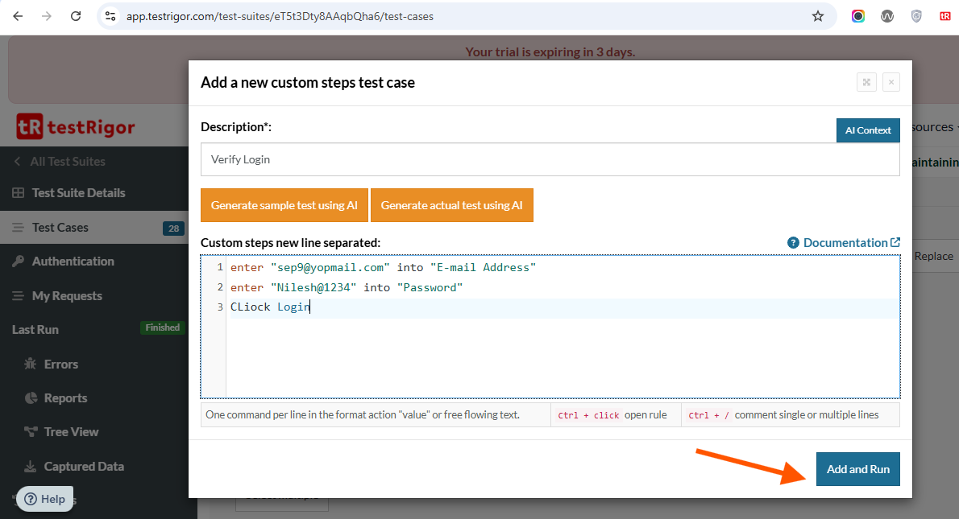

Click on Add and run button

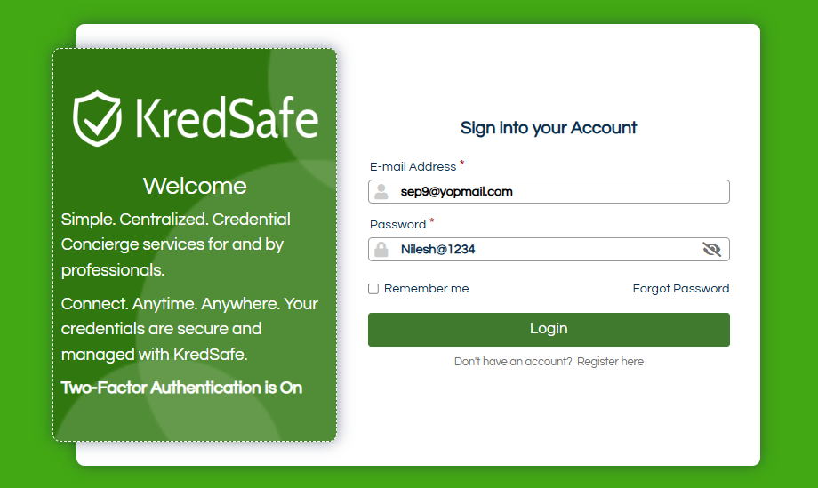

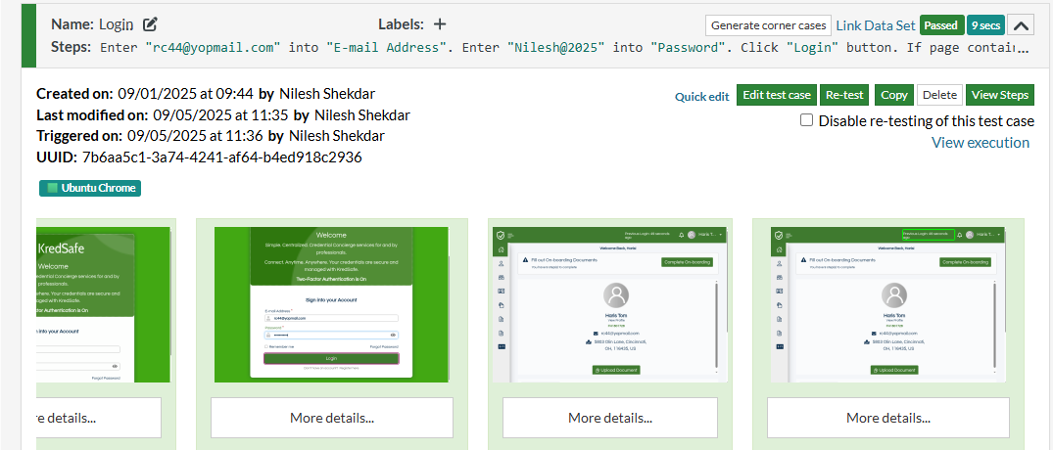

-Test pass successfully shows in Green

-We can we view all step by click on view steps.

-We can edit test case by click on Edit test case

Create Test Data –

In **TestRigor**, **Test Data** refers to the **dynamic or static data** used during test execution—like usernames, passwords, form inputs, etc. It allows you to create **flexible**, **scalable**, and **realistic** test cases by separating the data from test logic.

Url <https://app.testrigor.com/test-suites/eT5t3Dty8AAqbQha6/test-data/variables>

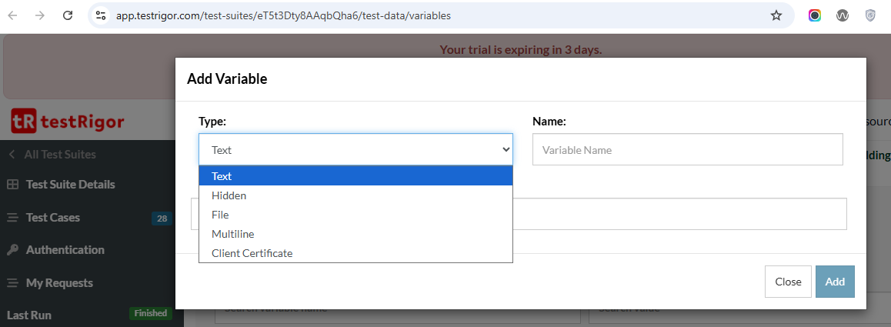

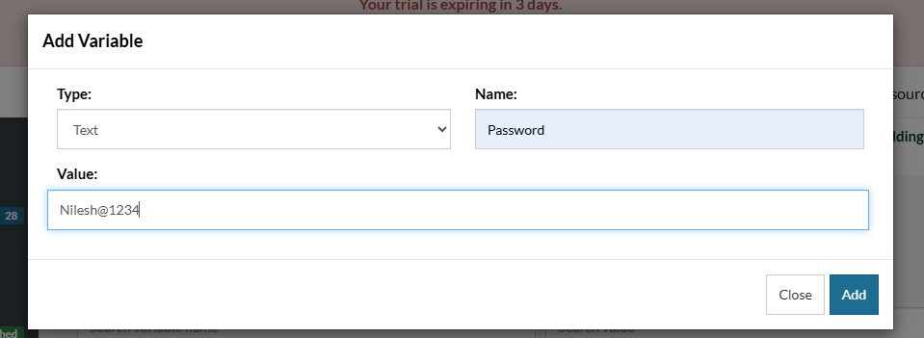

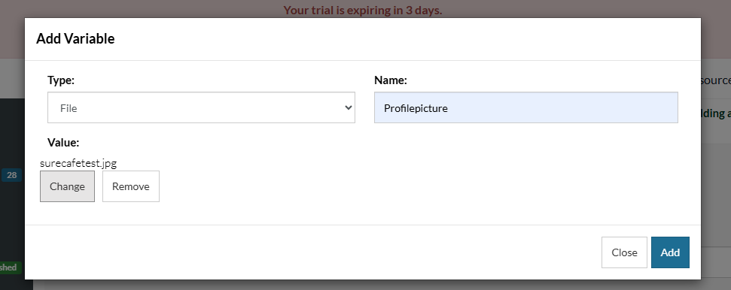

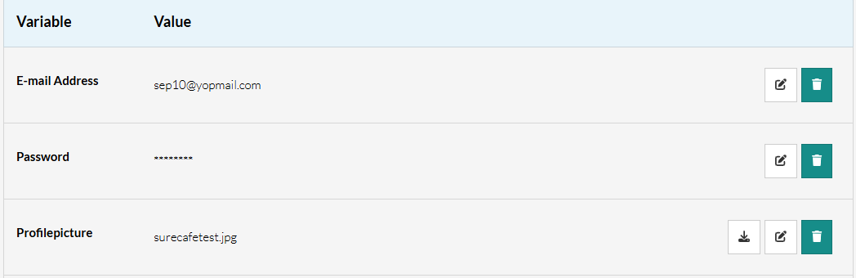

Edit test Data-

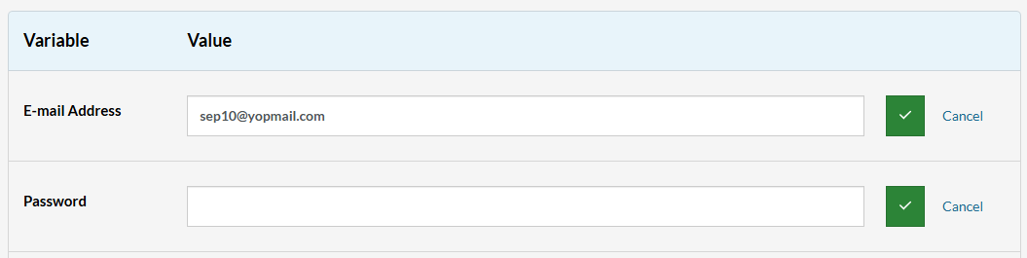

Create Data Sets-

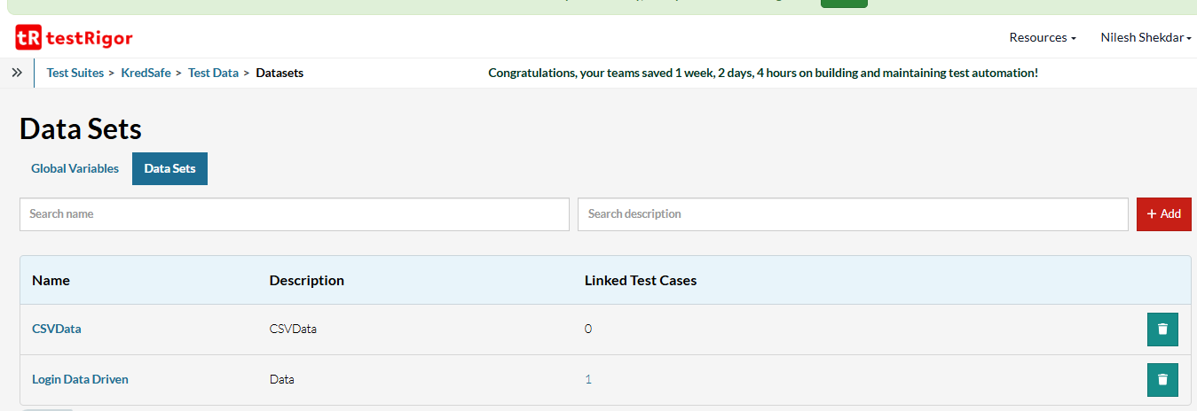

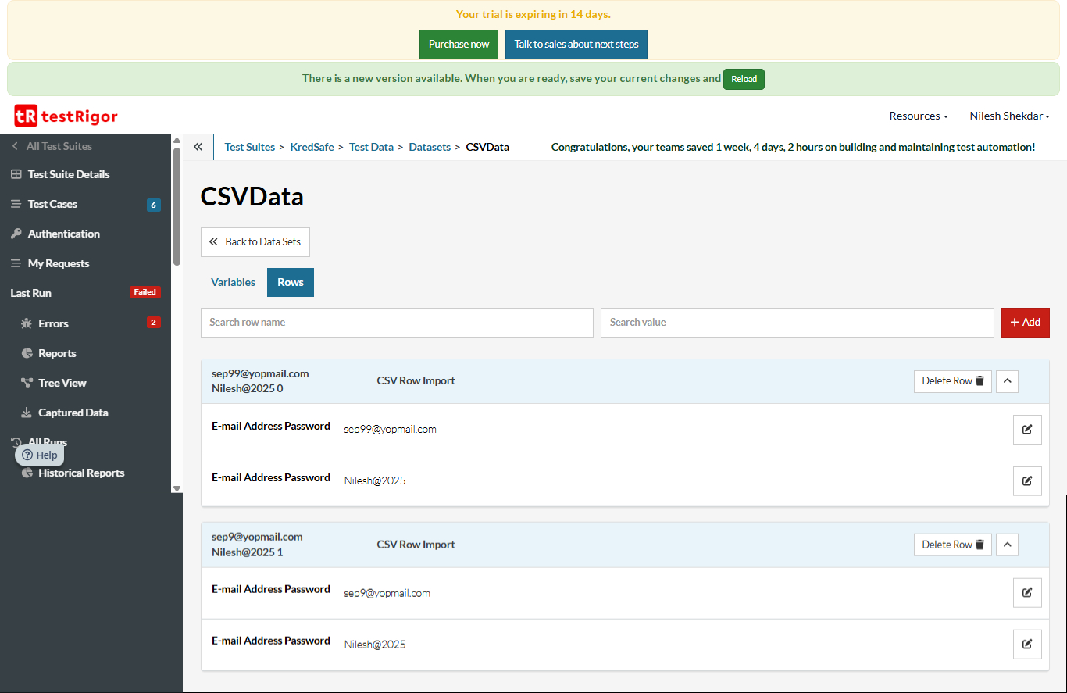

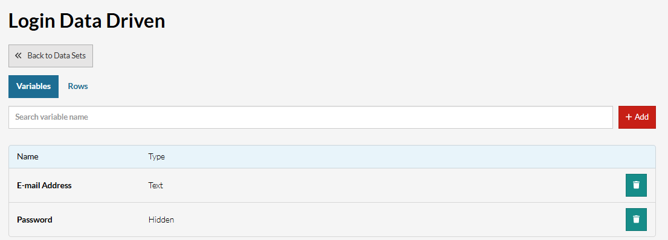

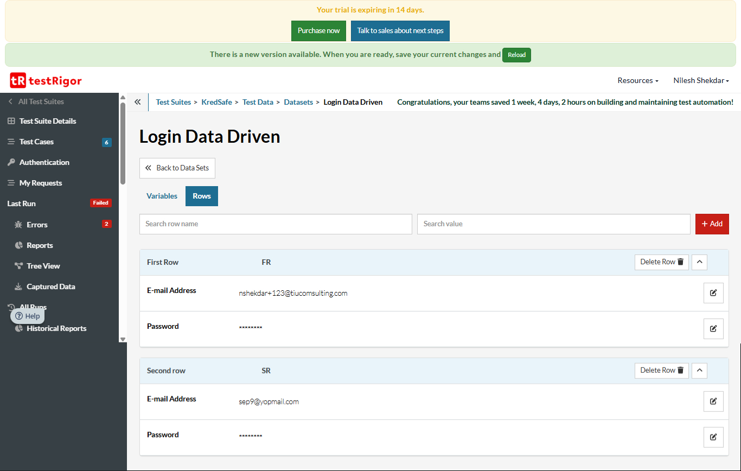

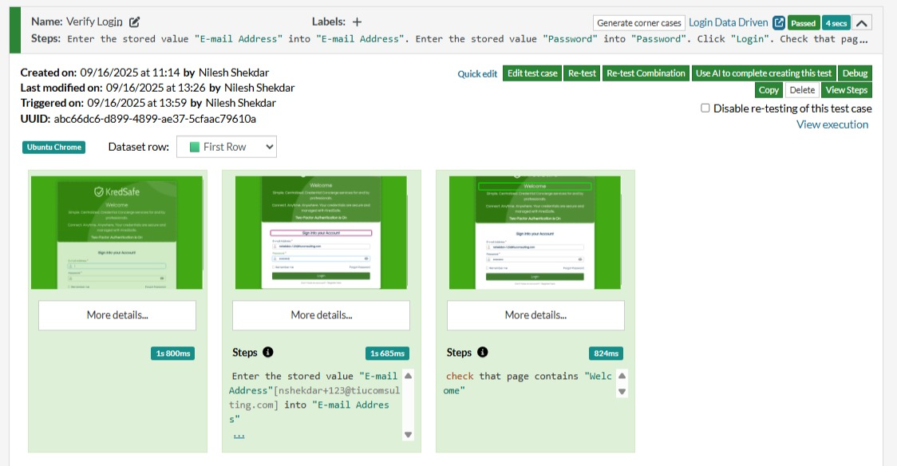

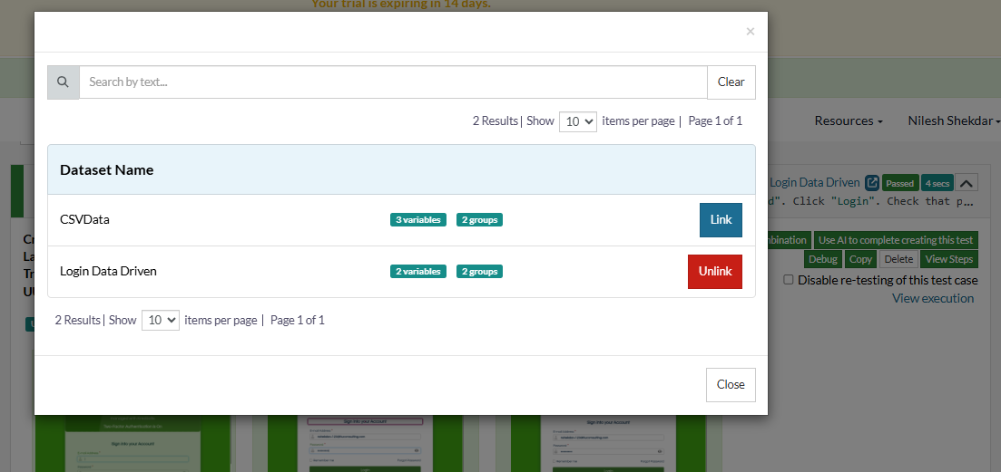

Create Reusable Rule –

A **Reusable Rule** (sometimes called a shared step or custom action) is a named set of one or more test steps written in plain English, which can be called from other test cases.

<https://app.testrigor.com/test-suites/eT5t3Dty8AAqbQha6/rules>

Create rule for Login

Enter the stored value "E-mail Address" into "E-mail Address"

Enter the stored value "Password" into "Password"

Click on the "Login" button

Check that the page contains "Welcome"

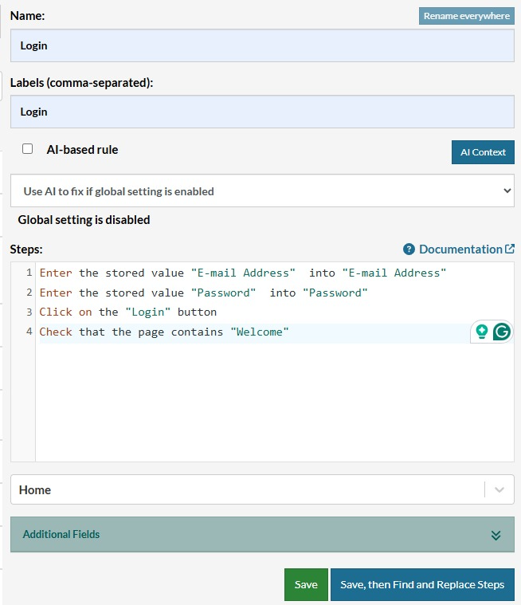

Click on save Button

If you want check replace step click on Save, the Find and Replace Steps

How Use Reusable rule-

If user want to login just select Login rule and login will done.

If need change user and password update in Test data only.

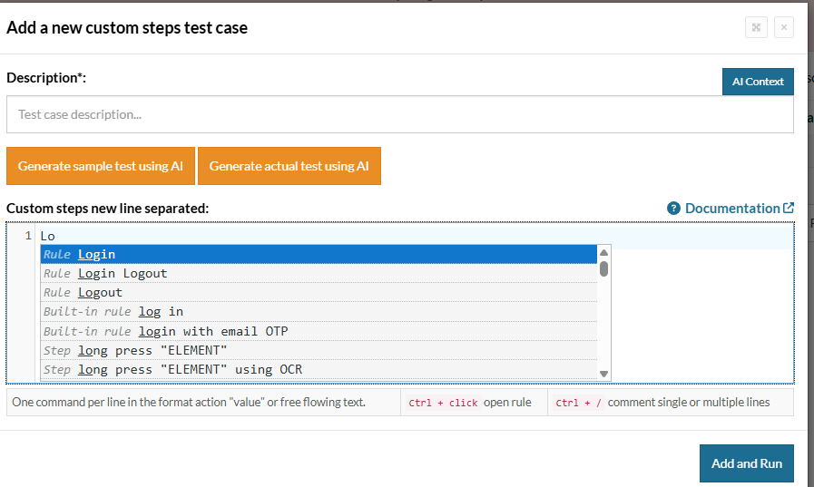

Analysis Of Test cases for Pass and Fail

View detailed test results:

1. Step-by-step logs

2. Screenshots on failure

3. Video recordings (in some tiers)

4. Performance metrics

5. Debug directly in the dashboard

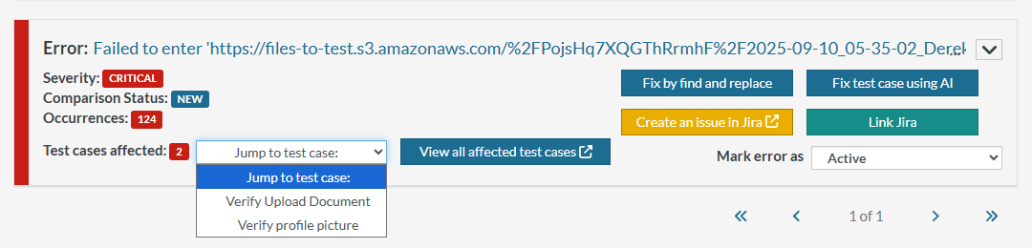

1 .Create an issue in Jira

2. Repost Use in Jira

3. Find and Replace test Steps

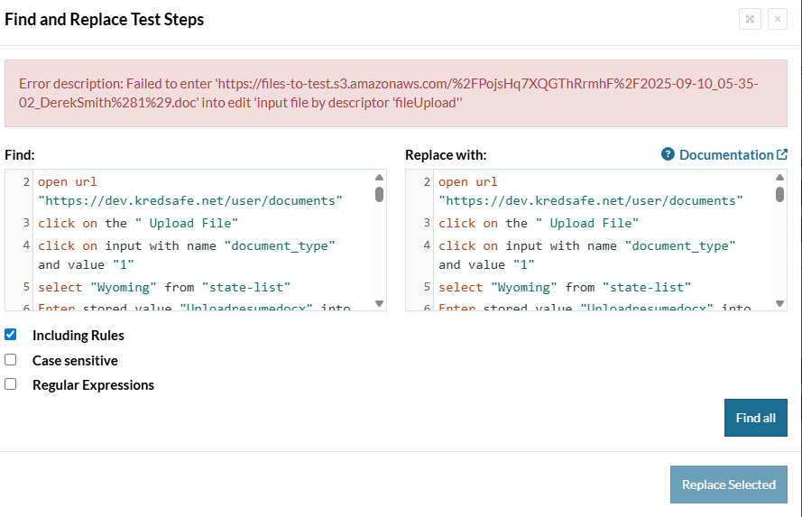

4. View can we all affected test Case

5. Jump to test case while selecting test case from list.

Choose and run test cases on different browsers-

Browsers (Chrome, Firefox, Safari, Edge

Devices (real or emulated

Parallel execution (for speed)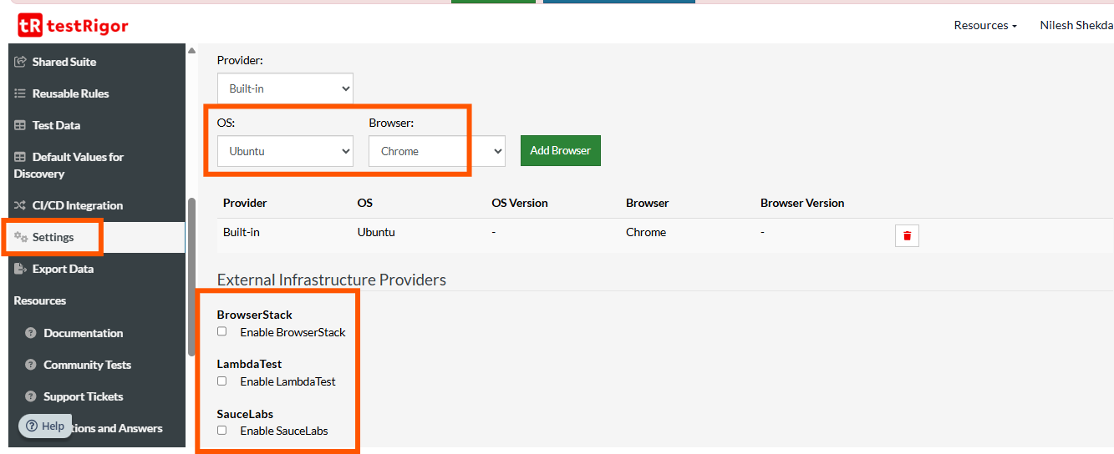

Configure CI/CD Integration

Integrate with:

GitHub Actions

GitLab CI

Jenkins

CircleCI

Others via API or CLI

TestRigor’s Test Case Recorder

Chrome Extension

TestRigor's Test Case Recorder is a built-in feature that allows you to automatically capture user interactions with your application (like clicks, form inputs, navigation, etc.) and convert them into plain English test steps.

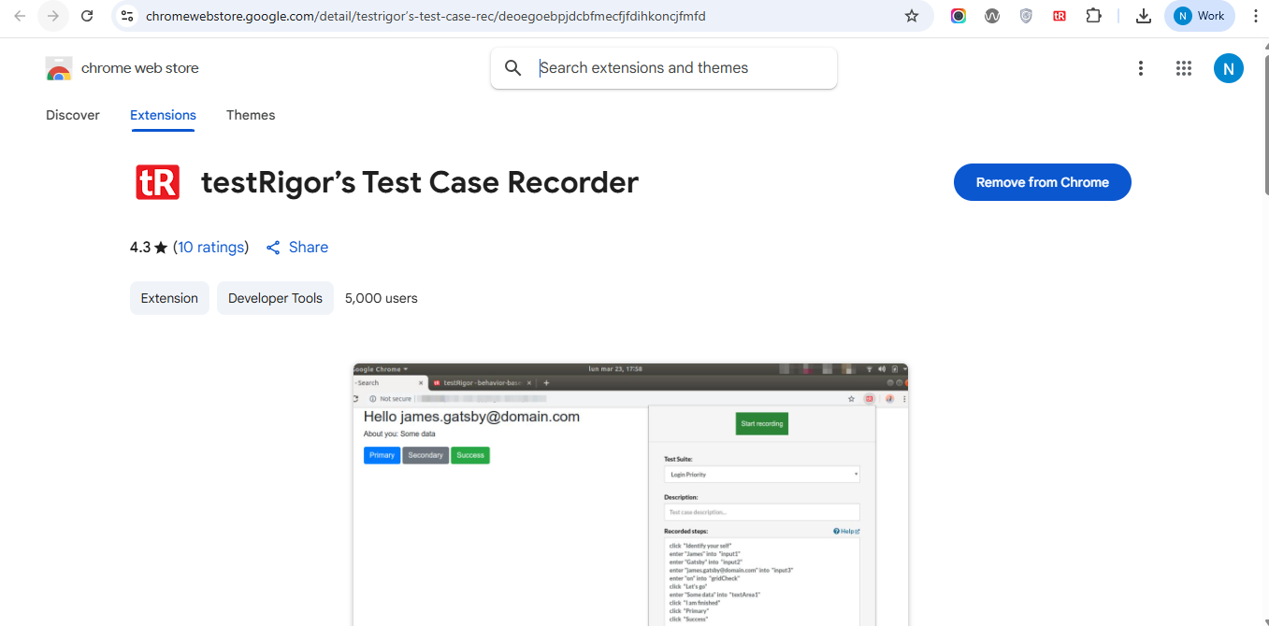

How setup testRigor’s Test Case Recorder-

Install the Chrome Extension-

Go to the Chrome Web Store (or another Chromium‑based browser) and search for “testRigor recorder” or “testRigor Test Case Recorder”.

Click “Add to Chrome” → “Add extension” when prompted. TestRigor

Pin / Enable the Extension

After installation, pin the extension icon so it’s visible in the toolbar. TestRigor

Ensure incognito mode is disabled for the extension (extension won’t work properly in incognito unless explicitly allowed / supported) or that permissions are enabled.

Start Recording

Click the testRigor extension icon in Chrome.

Click “Start new recording”. The icon should blink / indicate recording has started.

TestRigor

Perform the actions to be recorded in the web app (navigation, form fills, clicks, etc.). TestRigor will capture these actions and generate plain‑English test steps.

TestRigor

Stop Recording & Save Test Case

Once done with your flow, click the extension again and “Stop recording”.

TestRigor

In the popup, pick the Test Suite you want to save into, fill in a description for the test case.

Tools QA

Click “Add and Run” (or similar) to save the test case into your suite.

Edit & Run

After the test case is saved, you can edit the steps (plain English), update any hard‑coded items to make them more robust.

TestRigor

Then run the test from the testRigor dashboard with the desired browser settings, etc. View screenshots, logs, errors etc.

testRigor

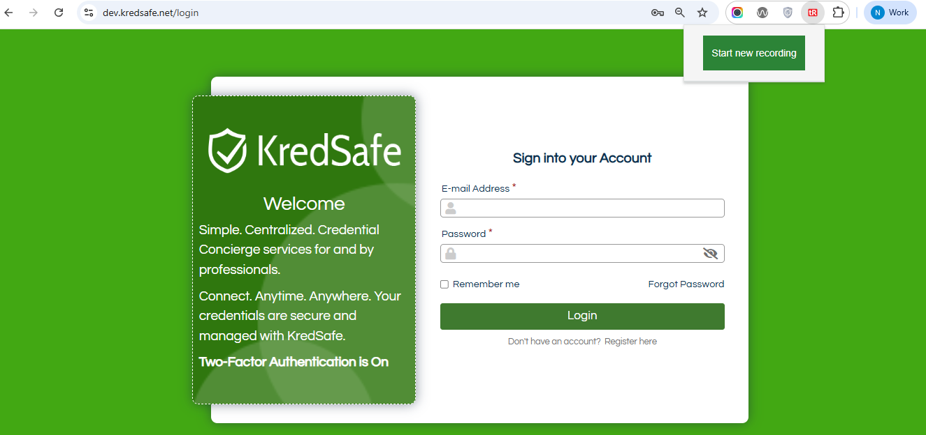

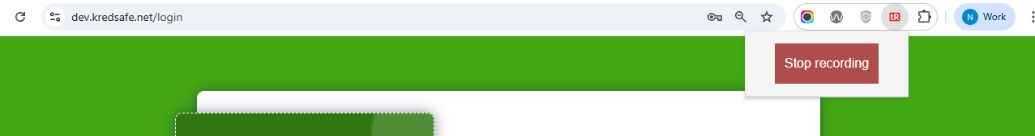

. 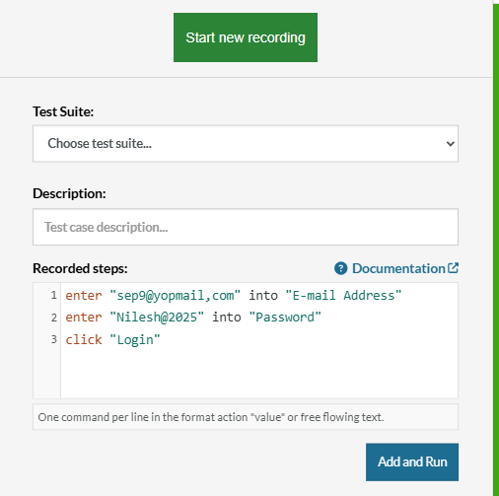

Verify Test case execution result-

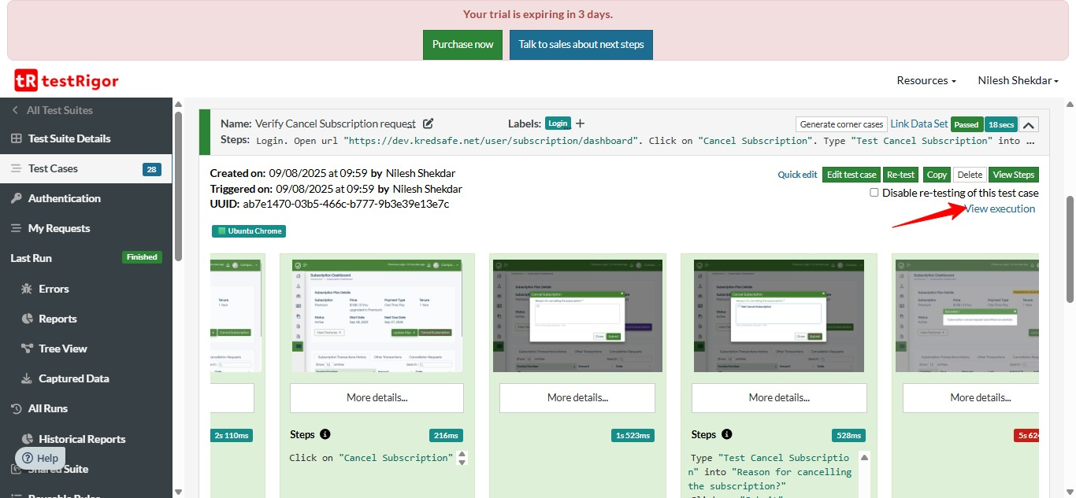

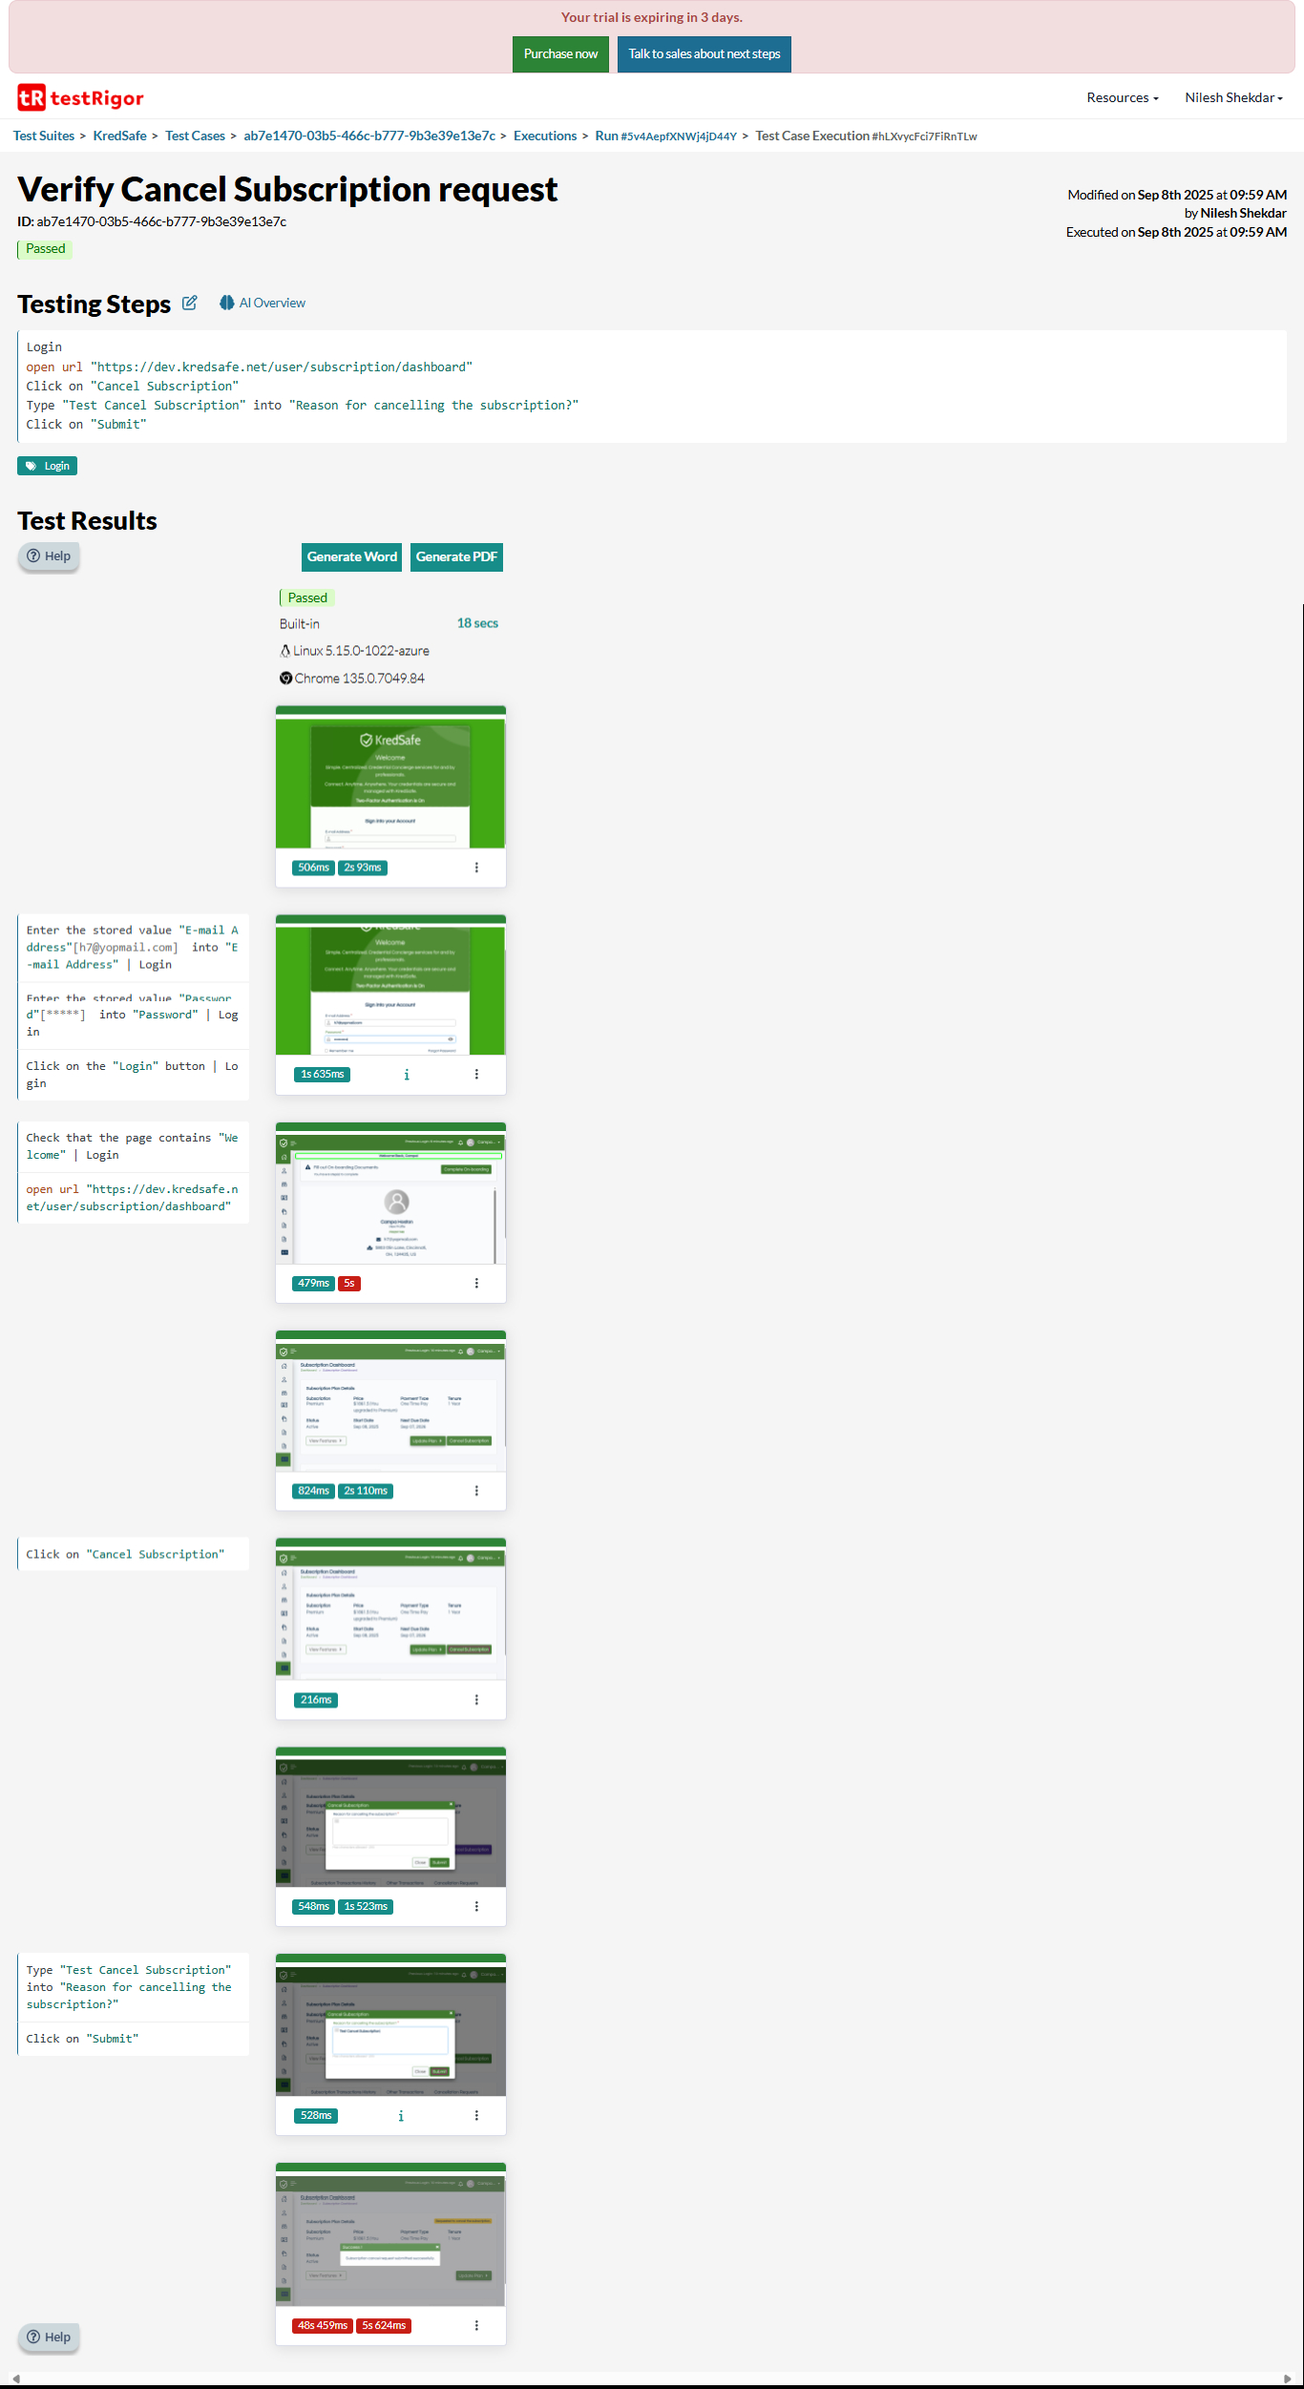

Download Word-

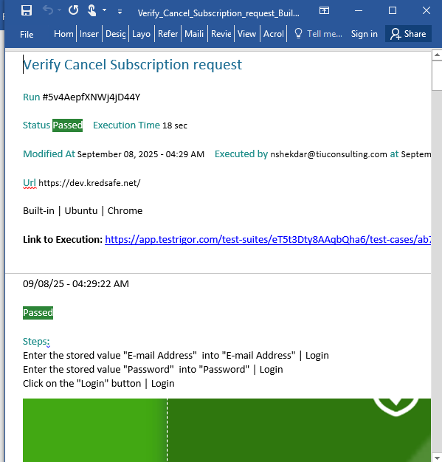

Generate Pdf

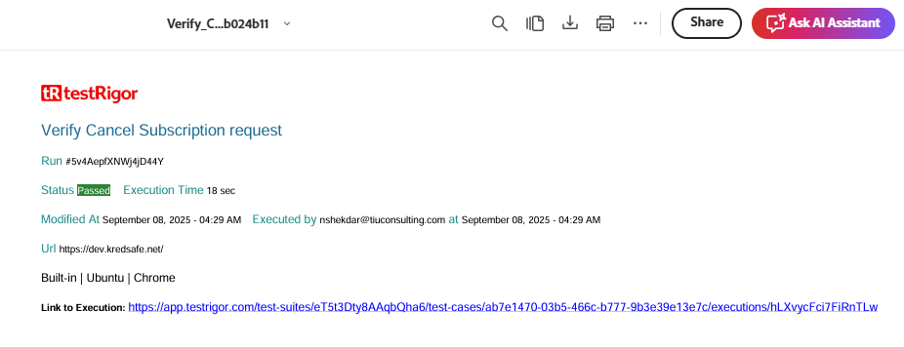



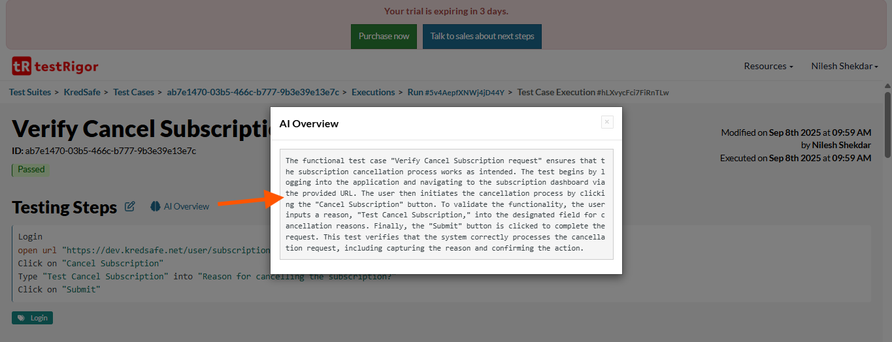

Reports-

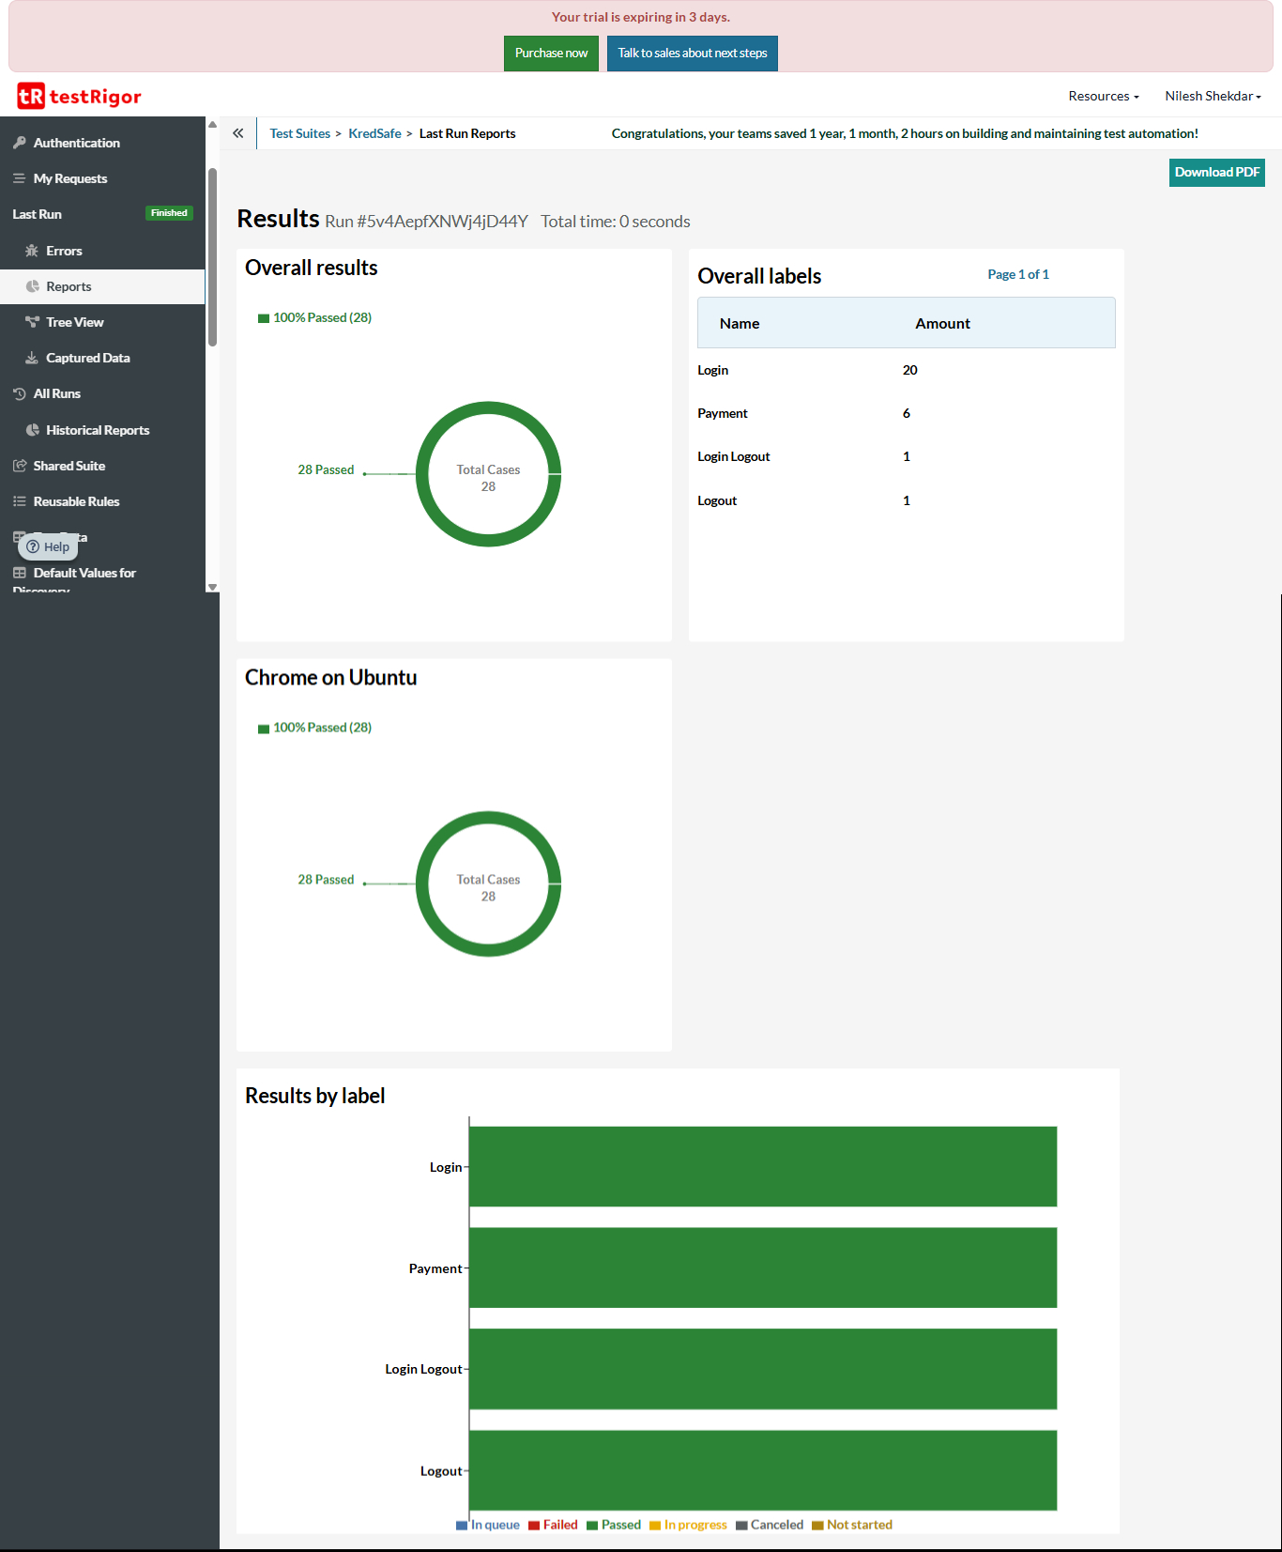

Tree View

-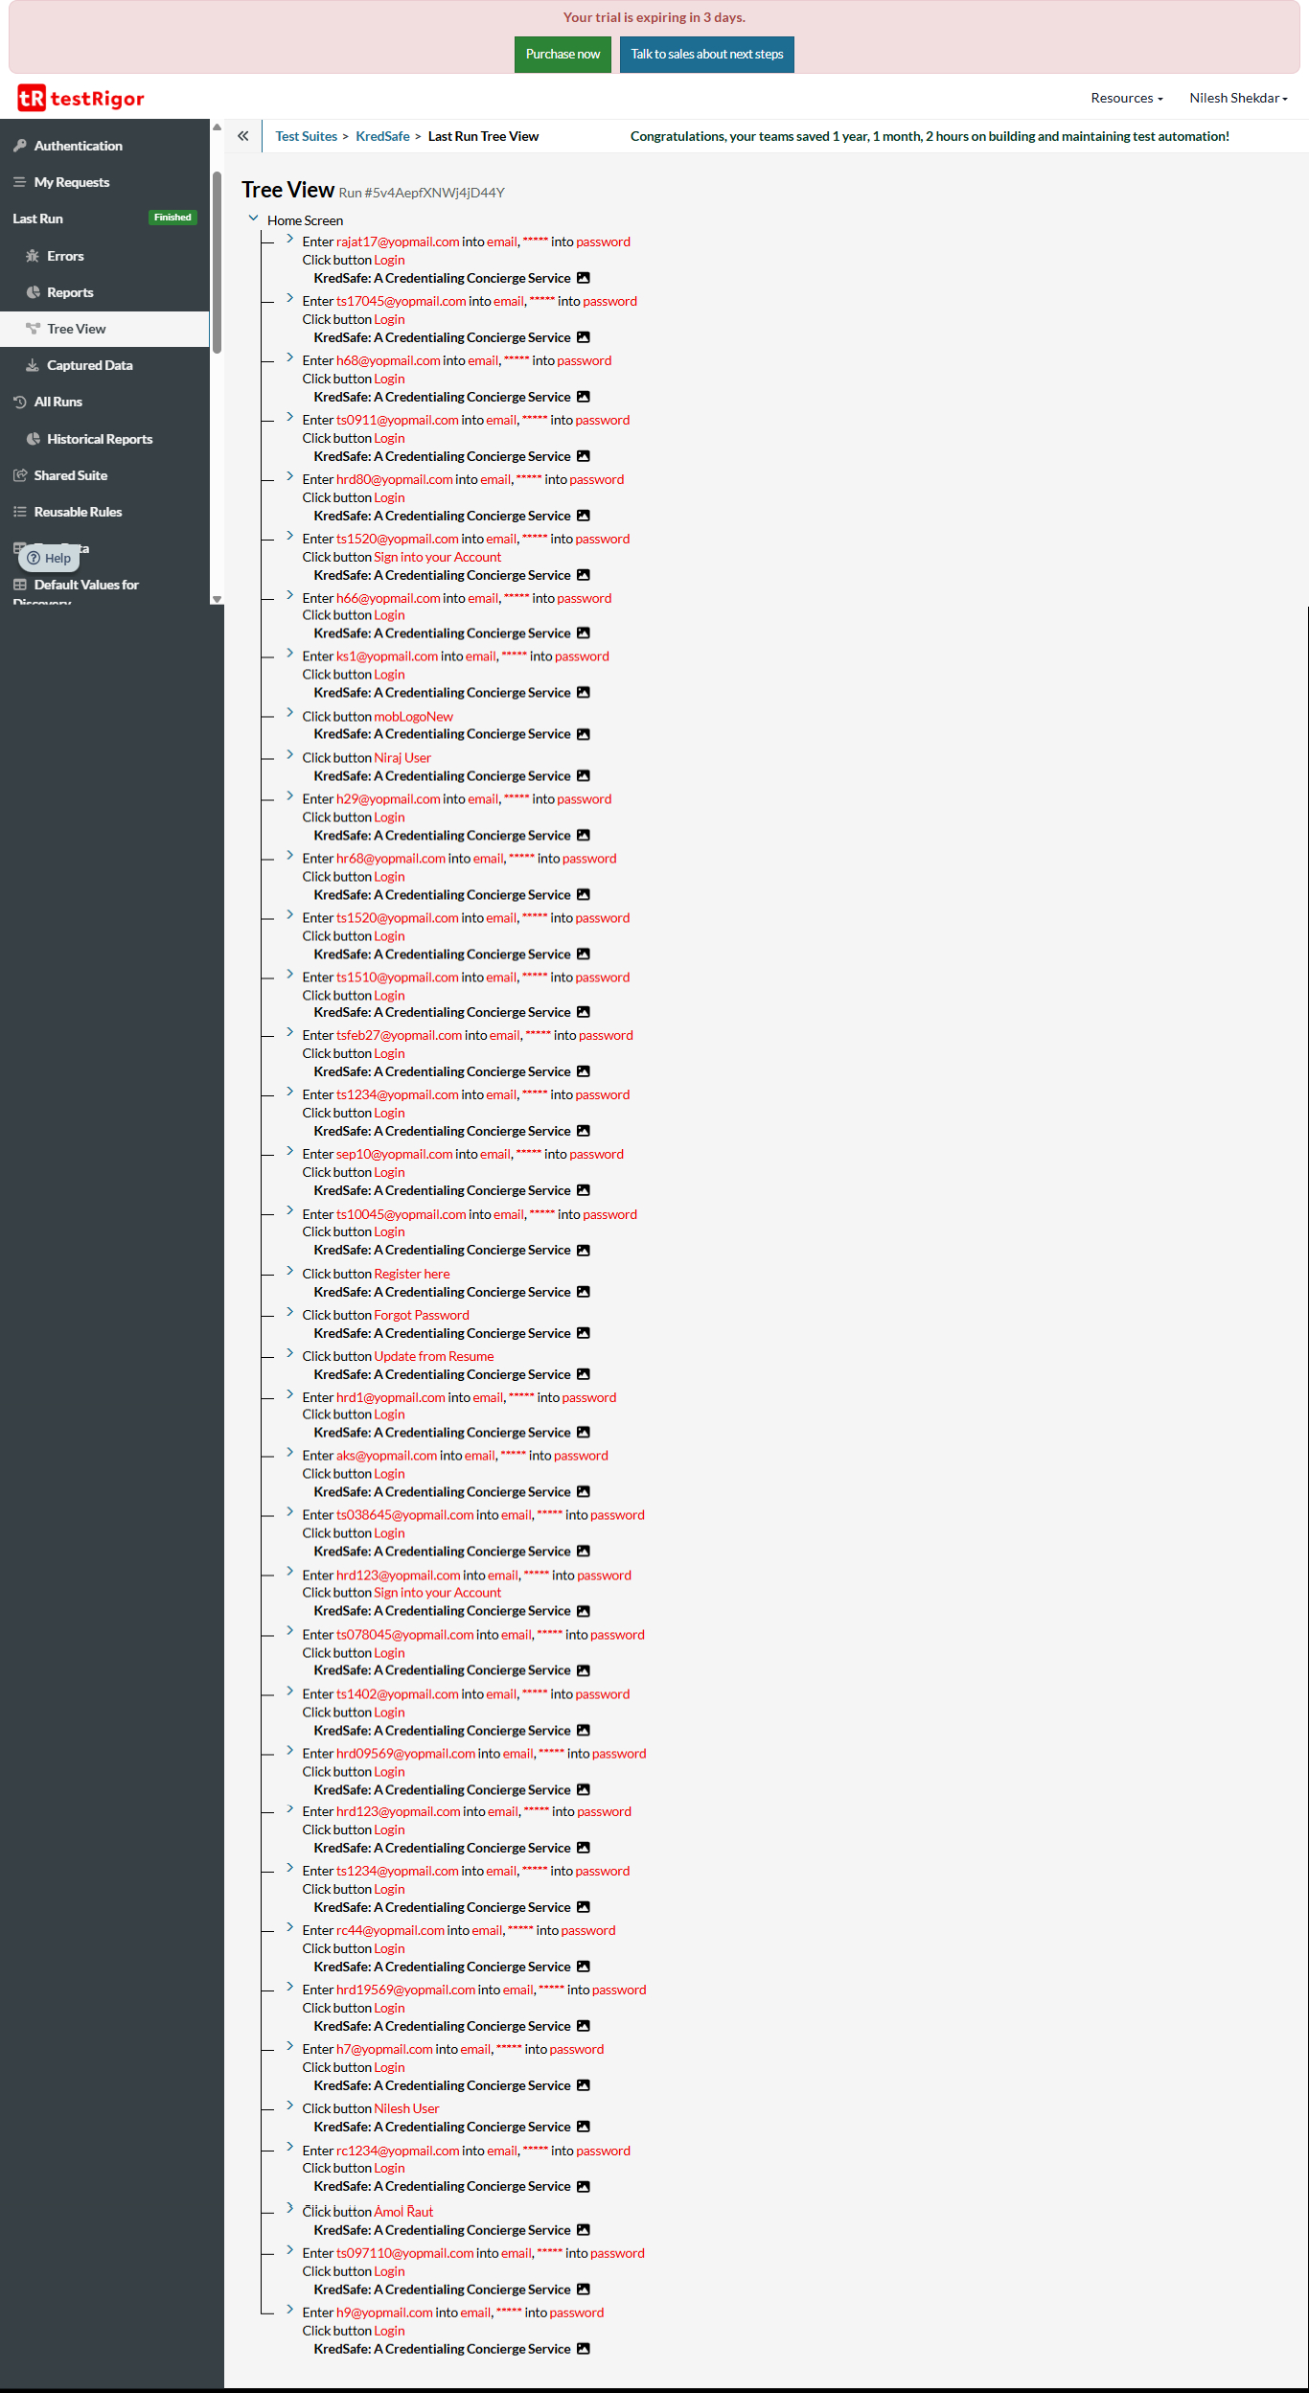

Captured Values-

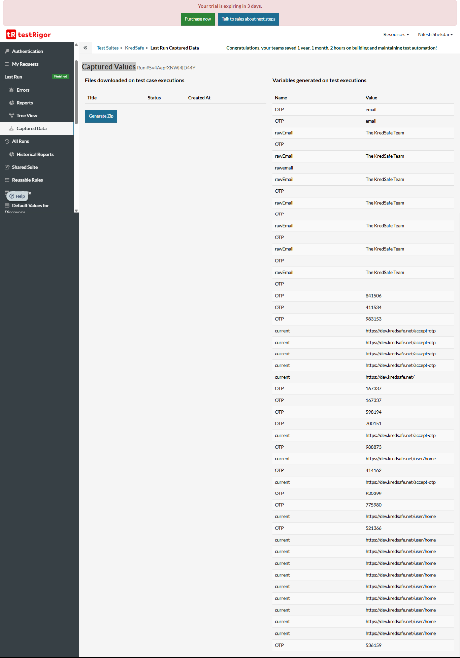

Edit Rule-

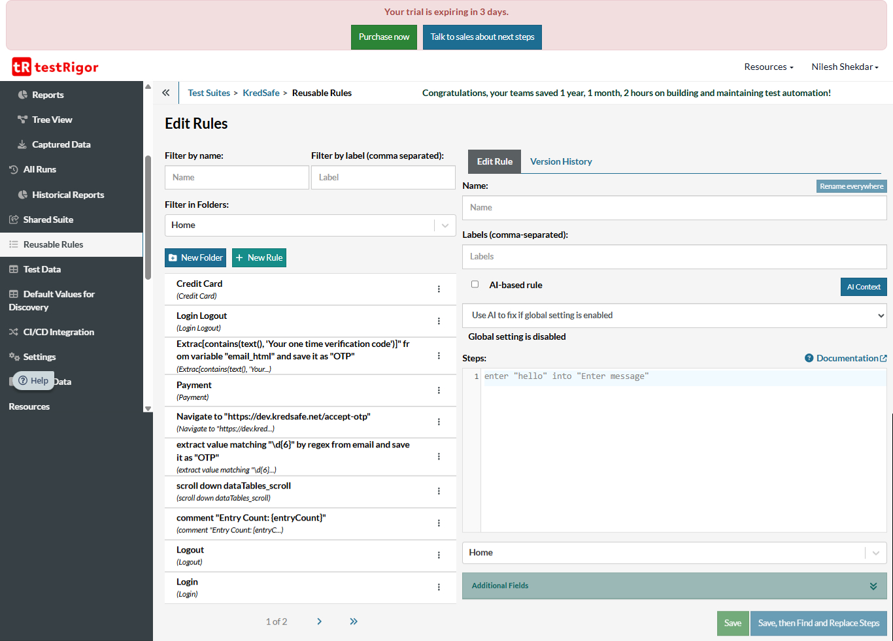

Historical Reports-

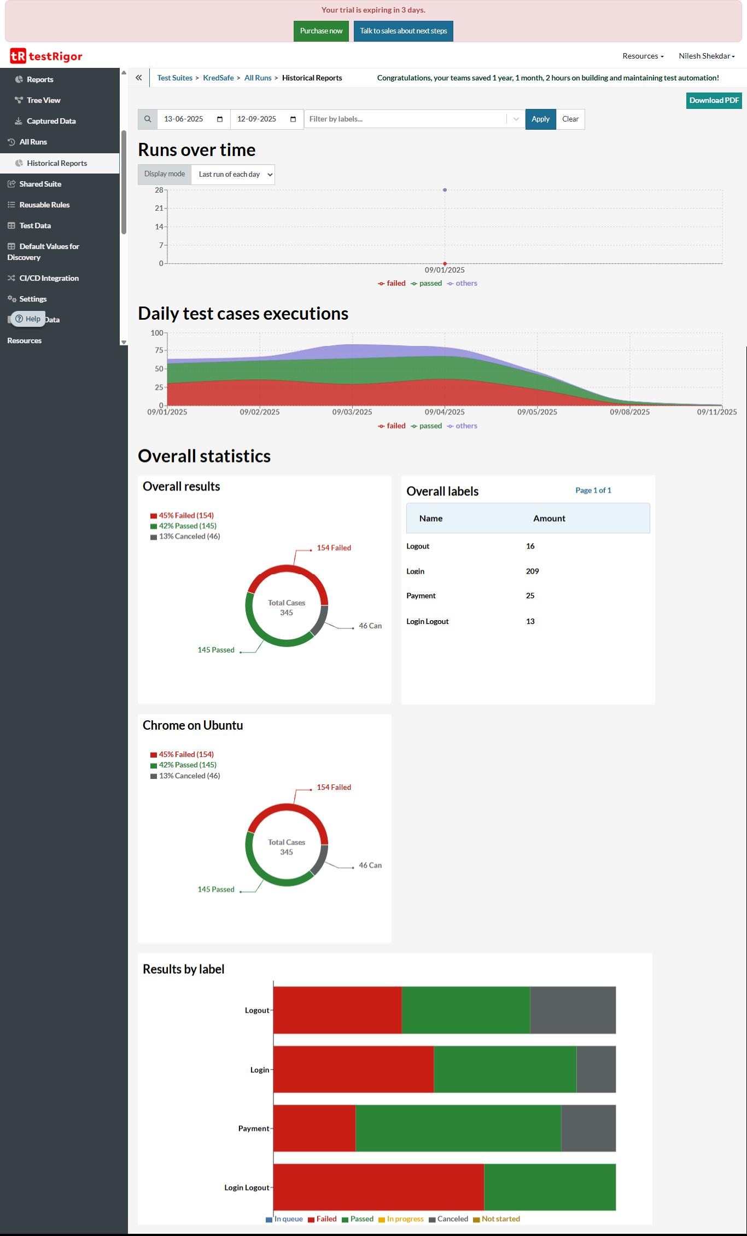

Test Data-

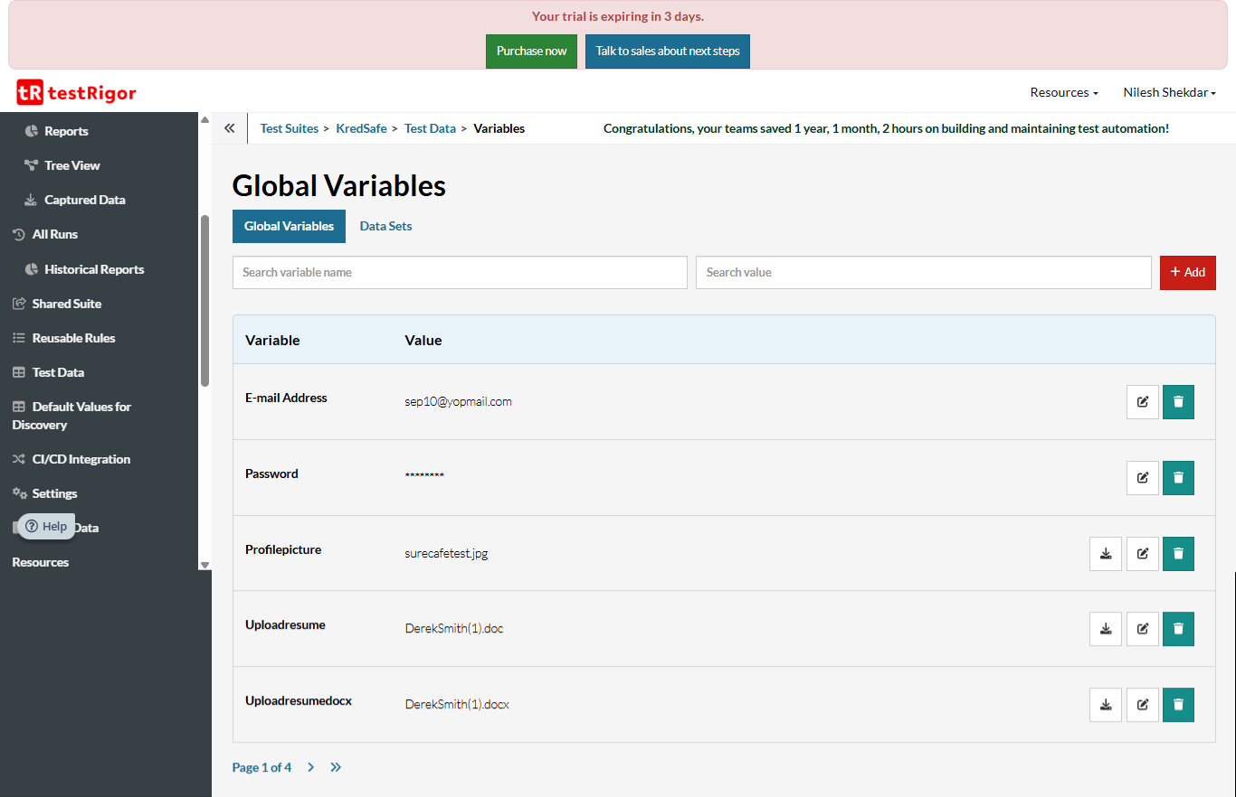

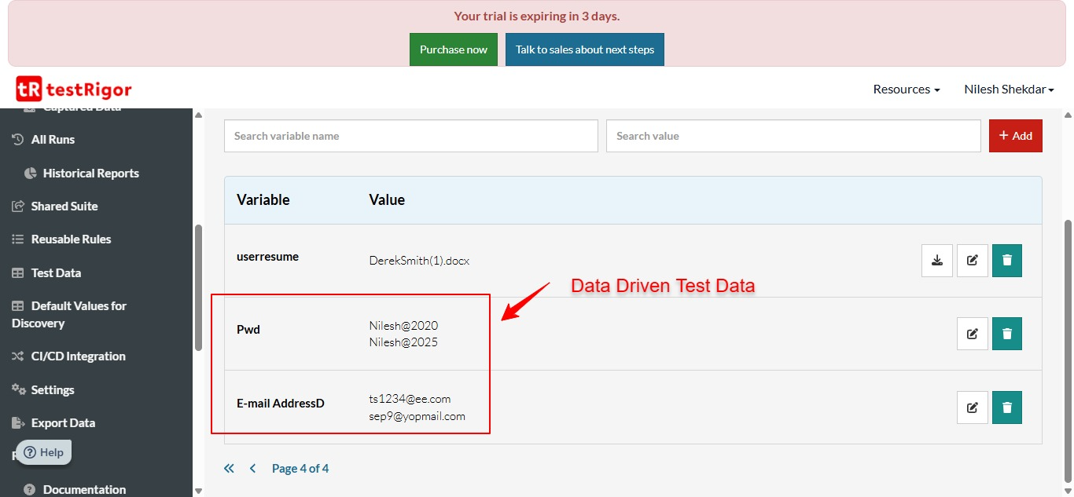

Setting-

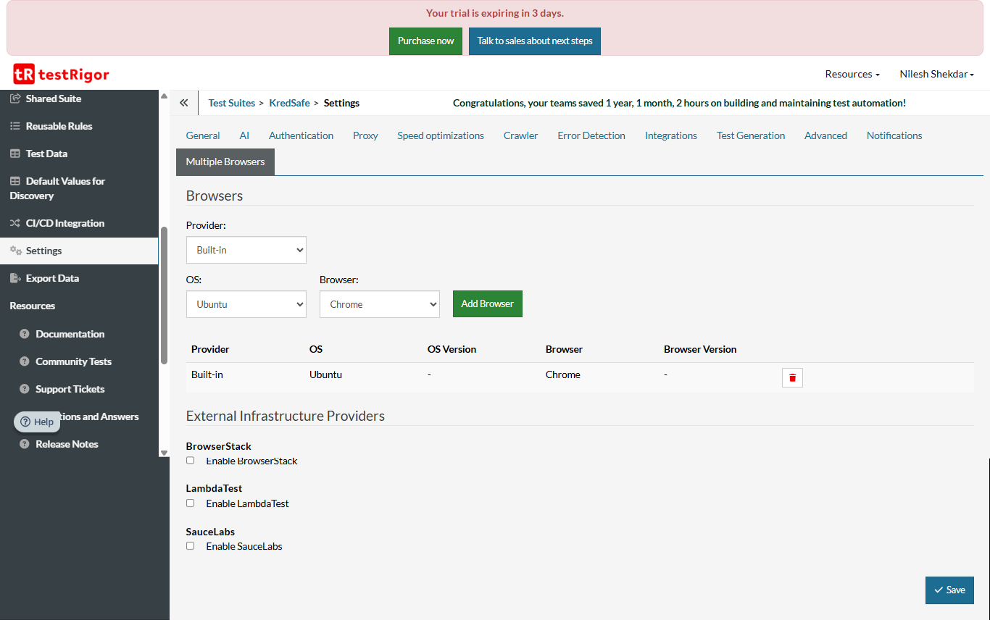

Documents-

https://testrigor.com/docs/langu

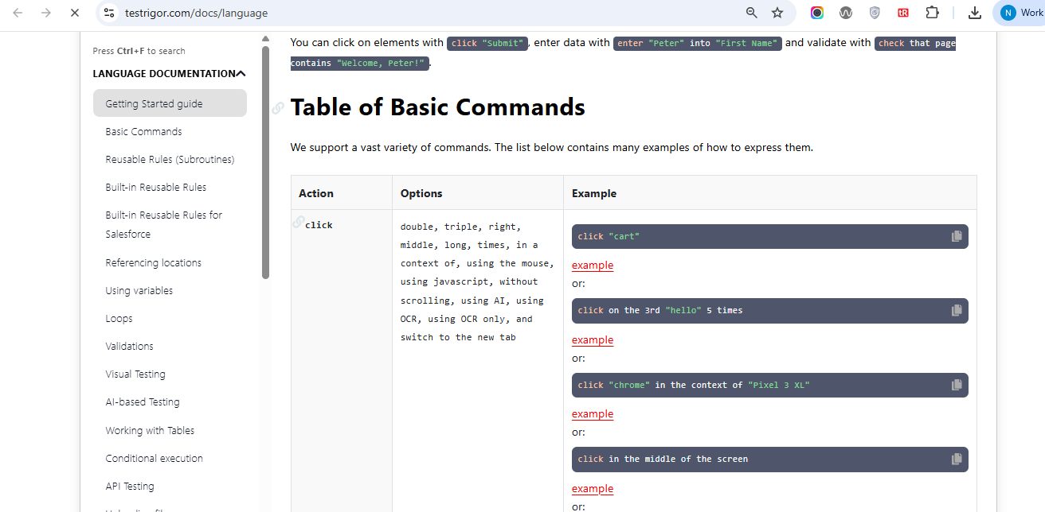

Tutorials -

<https://testrigor.com/tutorials/>



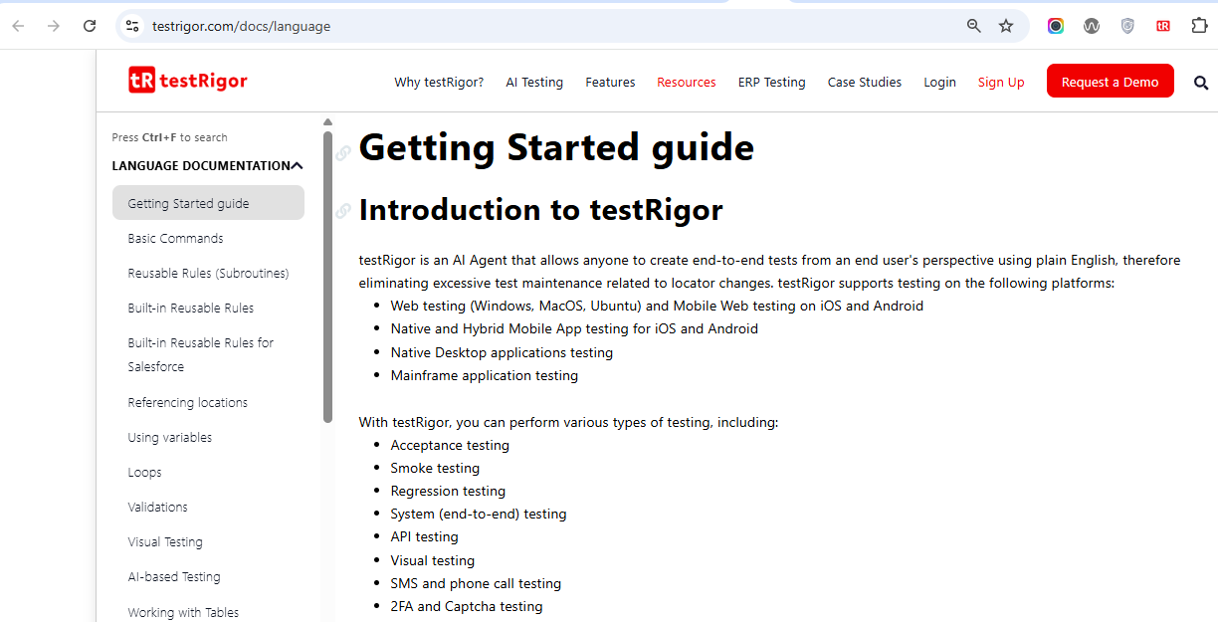

Test Cases

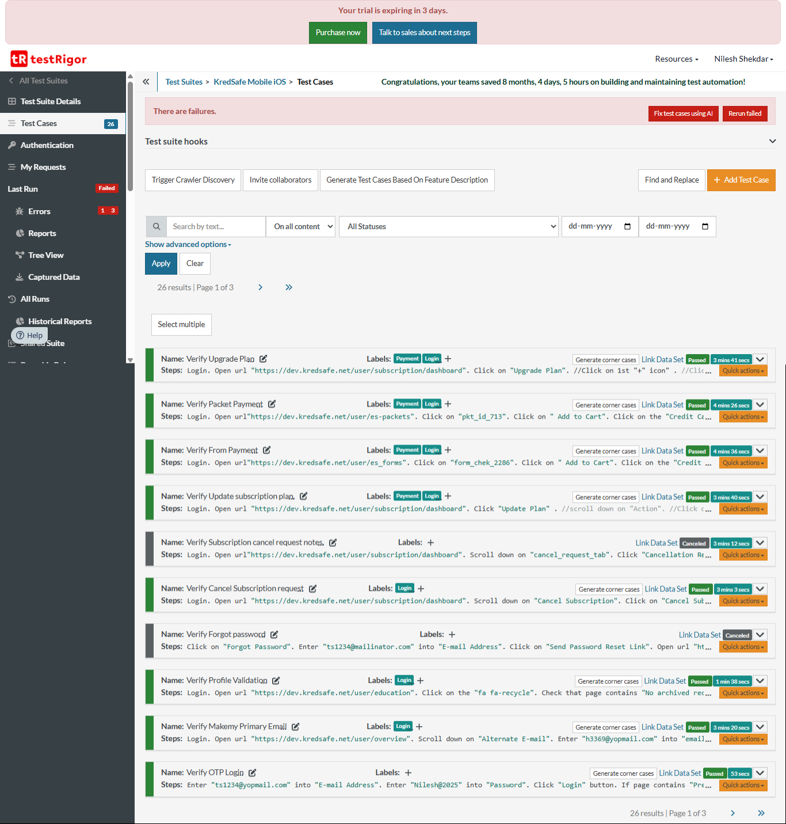

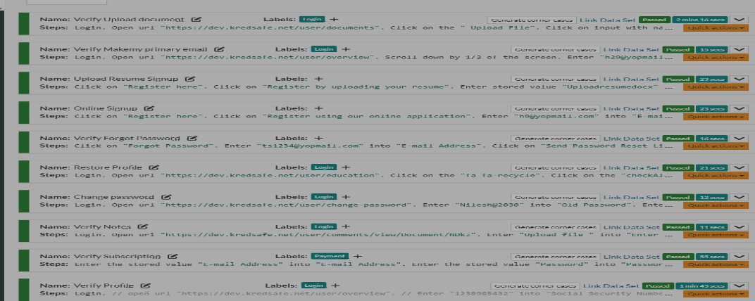

|  |
| --- |
| C:\Users\Admin\AppData\Local\Microsoft\Windows\INetCache\Content.MSO\5F9B2E45.tmp |

Documents-

The following action and option used to created test cases.

|  |  |  |  |
| --- | --- | --- | --- |
| Sr NO | Action | Option | script |
| 1 | click | click,switch to new tab,press | click on "Submit " button switch to original tab press "submit" |
| 2 | type | type | type "test" into "username" |
| 3 | generate | unique email, unique name, | generate unique name enter into "Name" and save as "generatedName" |
| 4 | enter | enter, select | enter "user" into "username " enter stored value "user" into "username " select"cityname"from the "cityid" select 1st option from "cityid" |
| 5 | check | page ,element | check that page contains"Welcome" check that page does not contain "Welcome"  check that "amount" contains "1000.00" |
| 6 | hover |  | hover over 3rd "notification" |
| 7 | open new tab |  | open new tab open url "[www.test.com](http://www.test.com/)" |
| 8 | switch tab |  | switch to tab (1) |
| 9 | close tab |  | click on "tabuser" close tab |
| 10 | go back |  | click on "icon" go back |
| 11 | reload |  | enter "city" into "citylistid" reload |
| 12 | drag | element, file | drag "city" to "city1" |
| 13 | scroll | down,up,right,left | scroll down scroll down by 1/2 page scroll down until page contains "Submit" button |
| 14 | wait | time | wait 5 sec |
| 15 | grab value | element ,regex | grab value by template "######" and save it as "OTP" |
| 16 | extract | element ,regex | extract value by regex "\d{6}" from "email" and save as "OTP" |
| 17 | open url | url | open url "[www.test.com](http://www.test.com/)" |
| 18 | grab burl |  | grab url and save it as "currenturl" |
| 19 | upload file |  | Click on the "Upload image" button Enter stored value "Profilepicture" into the input file "fileUpload" |
| 20 | Reusable rule |  | "Enter the stored value "E-mail Address" into "E-mail Address" Enter the stored value ""Password"" into "Password" Click on the "Login" button" Check that the page contains "Welcome" |

Test Cases –

Using above action and options created the following test cases.

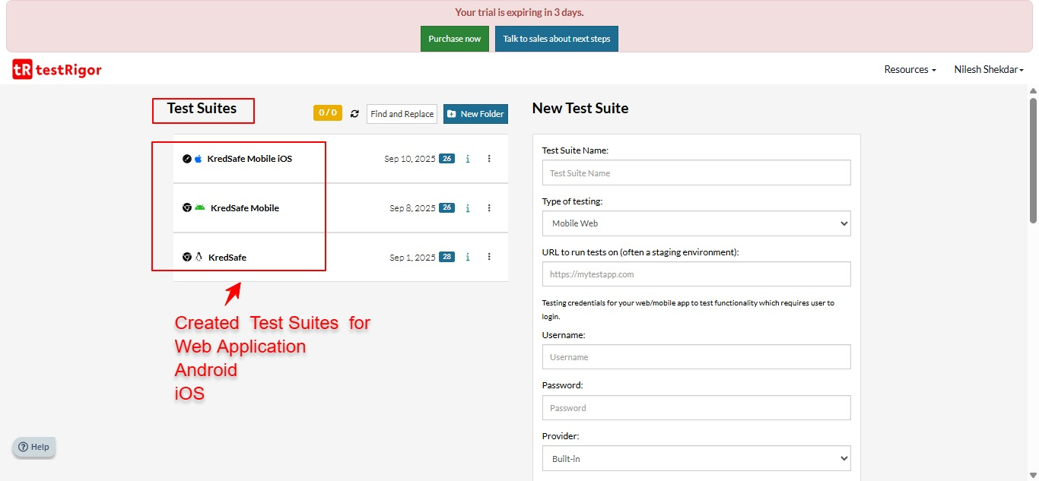

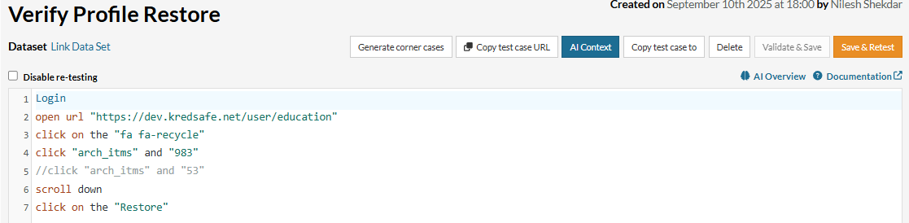

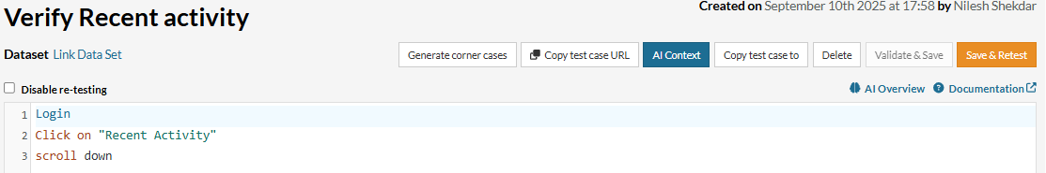

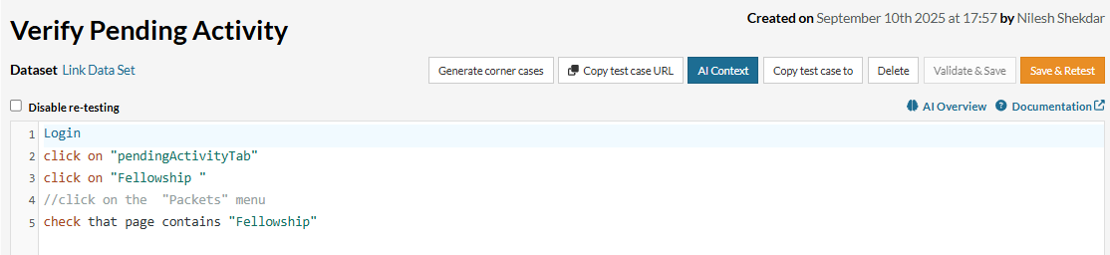

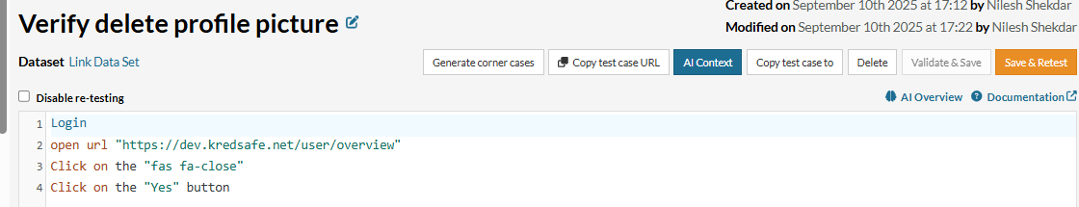

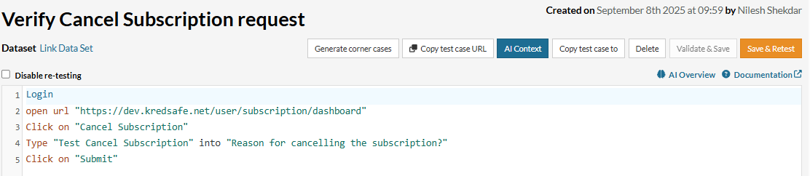

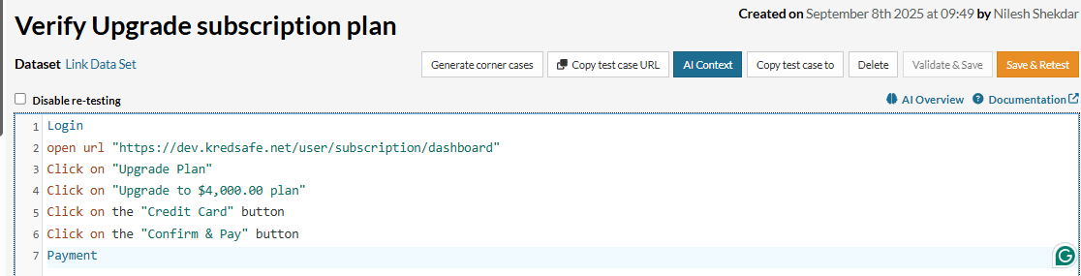

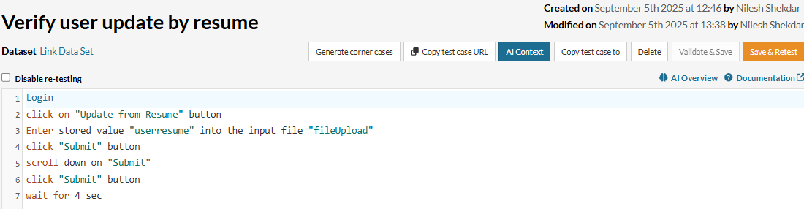

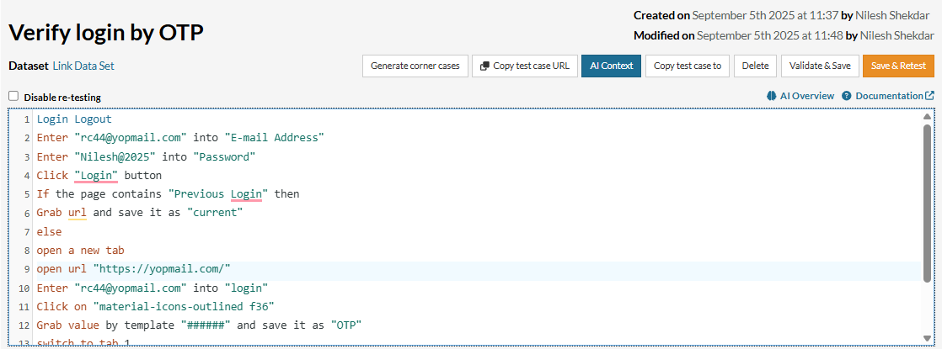

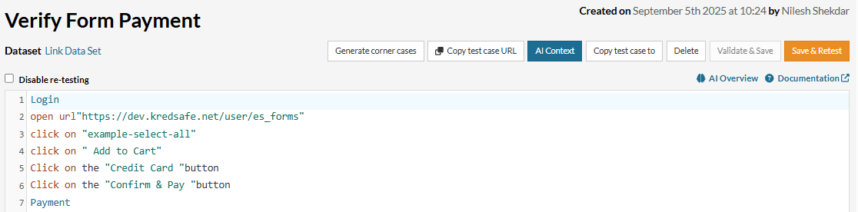

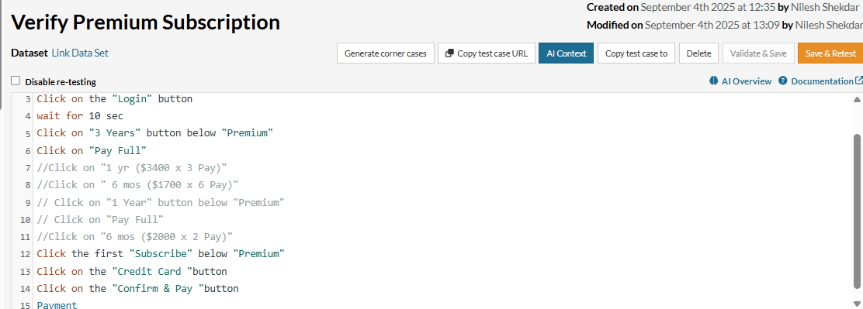

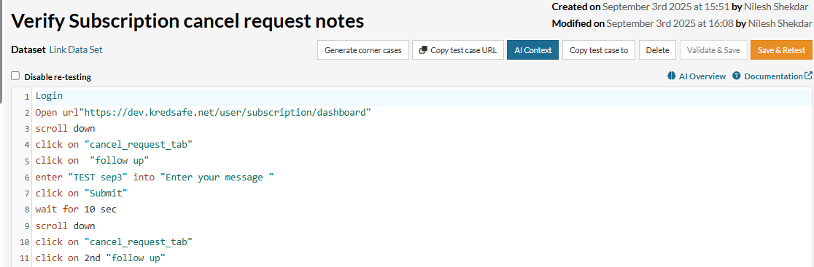

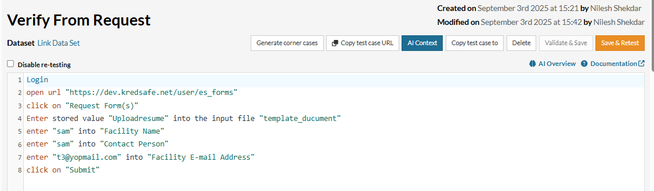

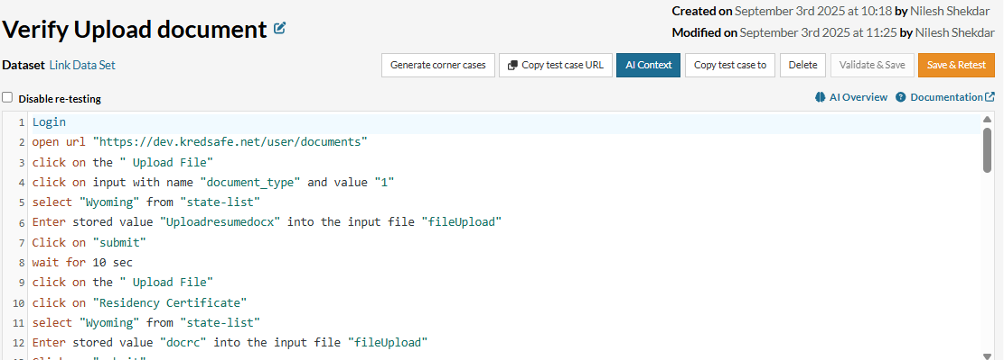

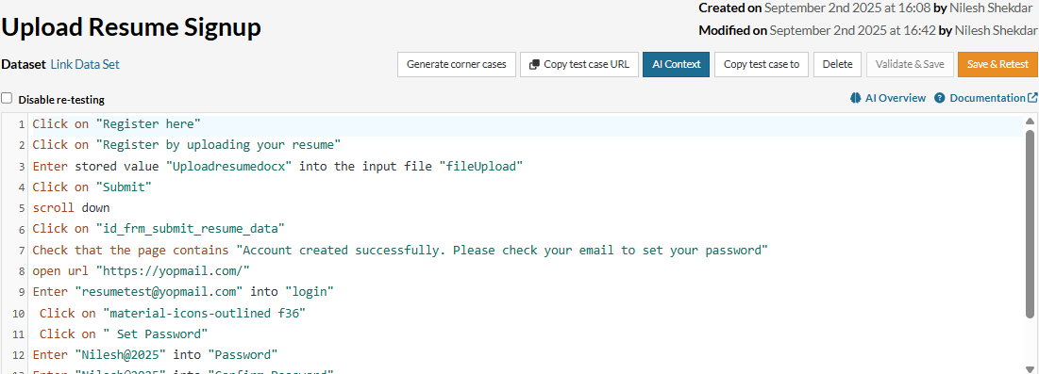

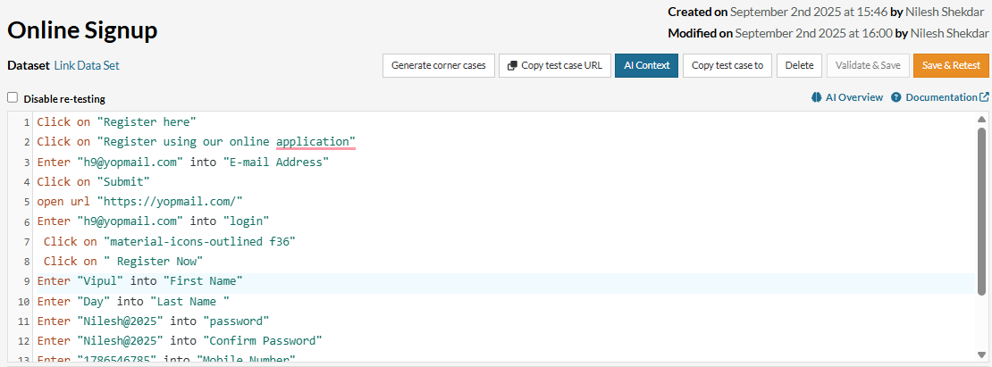

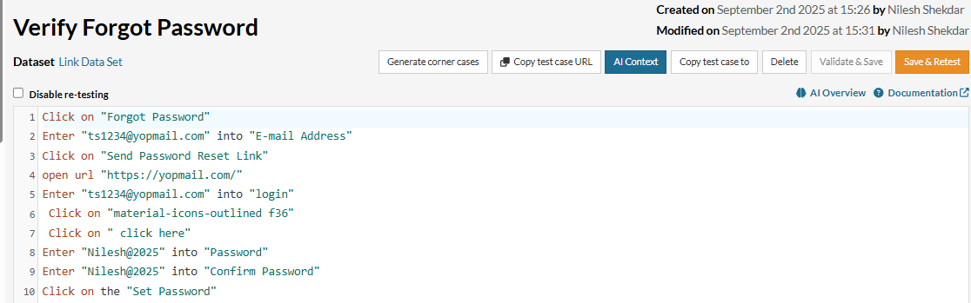

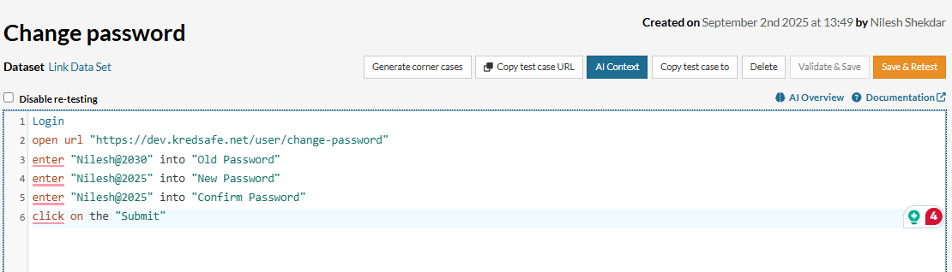

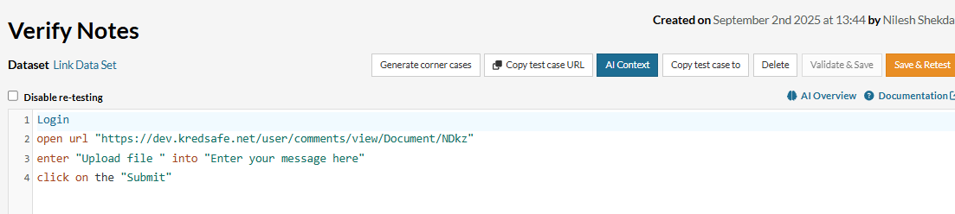

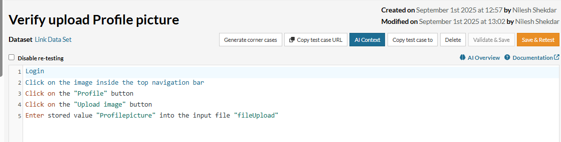

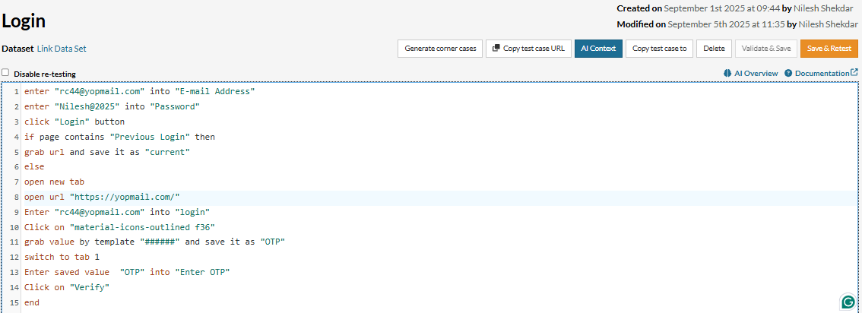

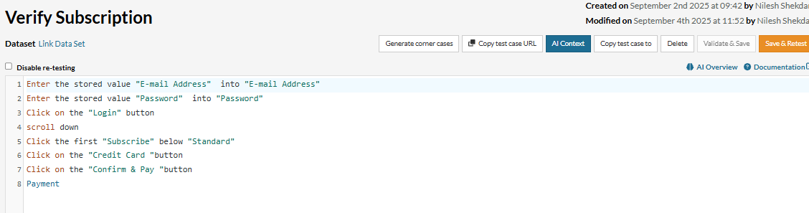

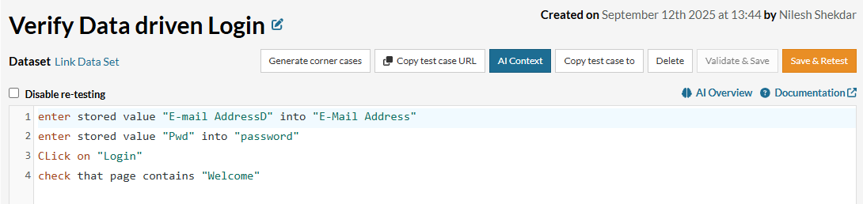

Generative-AI-in-Software-Testing-

## What is AI Testing?

AI-powered testing utilizes machine learning, natural language processing, and advanced data analytics to improve test accuracy, automate repetitive tasks, and even predict issues before they become critical. It showcases the potential to uplift traditional approaches to software testing. It offers a range of benefits, including:

* Automatically generating test cases, effectively reducing the time required for test creation
* Providing assistance during test creation, making the process simpler and more intuitive
* Improving test stability, thus reducing the presence of erroneous results
* Detecting elements on the screen, thereby aiding in more accurate test execution
* Automatically identifying issues, helping in proactive problem resolution, and enhancing the software’s quality
* Using AI to test AI, i.e., AI agents help you test LLMs, AI features, chatbots, and more

**Types of AI testing-**

### ****1. Functional Testing****

Verifies if the AI or software behaves as expected based on input.  
 E.g., Test chatbot responses for accuracy.

### ****2. Performance Testing****

Checks system speed, responsiveness, and stability under load.  
E.g., Load test a recommendation engine.

### ****3. Security Testing****

Identifies vulnerabilities and predicts threats using AI.  
 E.g., Test for adversarial attacks on AI models.

### ****4. Bias & Fairness Testing****

Ensures the AI model is free from unfair bias.  
 E.g., Check if a hiring AI discriminates by gender.

### ****5. Explainability Testing****

Validates that AI decisions are interpretable.  
E.g., Use SHAP or LIME to explain predictions.

### ****6. Data Testing****

Tests training data for quality, completeness, and correctness.  
 E.g., Validate data for an AI fraud detection model.

### ****7. Regression Testing****

### Ensures updates don’t break existing features. E.g., Test model retraining doesn’t cause new bugs.

### ****8. Adversarial Testing****

Tests AI against malicious or confusing inputs.  
E.g., Use distorted images to test image classifiers.

### ****8. Adversarial Testing****

Tests AI against malicious or confusing inputs.  
 E.g., Use distorted images to test image classifiers

### ****9. Model Drift Testing****

Monitors performance drops due to changing data patterns.  
 E.g., Detect accuracy decline in credit scoring AI.

### ****10. Ethical & Compliance Testing****

Ensures AI meets legal and ethical standards.  
 E.g., Check healthcare AI for GDPR/HIPAA compliance.

The role of AI in software testing-

I**ntelligent Test Case Generation** – AI creates and prioritizes test cases based on user behavior and past defects. *Improves coverage, finds critical bugs faster.*

**Test Automation Enhancement** – AI tools generate and self-heal test scripts, adapting to UI changes. *E.g., testRigor allows plain English scripting.*

**Test Execution Optimization** – AI speeds up testing by running only essential, high-priority tests. *Eliminates redundant test runs.*

**Defect Prediction & Root Cause Analysis** – Predicts where bugs are likely and explains causes clearly. *Focuses testing where issues are most common.*

**Visual & UI Testing** – AI compares UI elements across devices to catch visual issues. *Ensures layout consistency and accessibility.*

**NLP-Based Test Automation** – Write tests in natural language; no coding needed. *E.g., “click ‘Submit’ → check ‘Success’ message.”*

**AI in Performance & Load Testing** – Simulates real user behavior under load and suggests optimizations. *Helps with auto-scaling and performance tuning.*

**AI in Security Testing** – Automatically finds and prevents security flaws. *E.g., detects SQL injection risks in forms.*

**Continuous Testing in CI/CD** – AI automates testing in DevOps pipelines for quick feedback. *Only stable builds move forward.*

**Exploratory Testing** – AI mimics human testers to find edge cases and unusual bugs. *Covers what scripted tests might miss.*

**Benefits of Generative AI in QA:**

1. **Reduces Manual Effort** – Automates test creation, especially useful for regression testing, allowing QA teams to focus on complex tasks.
2. **Increases Test Coverage** – Generates diverse test scenarios to detect more bugs and improve software reliability.
3. **Ensures Consistency** – Delivers high-quality, repeatable tests with fewer human errors.
4. **Learns and Improves Over Time** – AI models adapt and enhance test accuracy as they encounter more data.
5. **Fits Seamlessly into CI/CD** – Speeds up testing in DevOps pipelines, improving development and delivery efficiency.

**Challenges of Generative AI in QA:**

1. **Irrelevant Tests** – AI may generate tests that lack context or don't align with real scenarios.
2. **High Computational Needs** – Requires significant resources, which can be a barrier for smaller teams.
3. **Workflow Disruption** – Adopting AI tools may require process changes and team retraining.
4. **Data Dependency** – Performance relies on high-quality, unbiased training data.
5. **Difficult Interpretation** – AI-generated tests can be hard to understand, especially when failures occur.

**Generative AI Use Cases in QA**:

**1. Generating Examples from Descriptions** – AI creates test cases or code snippets based on brief descriptions (e.g., “Test checkout process”), reducing manual effort. Tools like testRigor support this via prompt-based generation.

**2. Code Completion** – AI-powered tools like GitHub Copilot provide intelligent code suggestions by understanding the broader context, speeding up development and reducing errors.

**3. Generating Full Tests from Descriptions** – AI can generate complete, runnable tests and set up test environments from a simple description, minimizing manual setup.

**Generative AI Testing Tools:-**

Generative AI testing tools help automate test creation, improve coverage, reduce manual effort, and maintain test reliability.

### ****Types of Tools & Use Cases:****

1. **Automated Test Case Generation** – Creates test cases from requirements, user stories, or code, speeding up coverage.
2. **Test Data Generation** – Produces large, realistic datasets (including edge cases) for thorough testing.
3. **Self-Healing Automation** – Automatically updates test scripts when UI or code changes, reducing maintenance.
4. **Predictive Analytics** – Identifies high-risk areas using historical data to prioritize testing and find bugs early.
5. **Visual Testing** – Detects UI inconsistencies across browsers/devices to maintain layout and design integrity.

**The Right Generative AI Testing Tool:-**

### 1. ****Identify Your Testing Needs****

* **Test Coverage**: Choose tools based on the type (functional, performance, visual).
* **Automation Level**: Look for features like regression testing or predictive bug detection.
* **Test Complexity**: Ensure the tool handles edge cases if needed.

### 2. ****Integration with Existing Tools****

* **CI/CD Compatibility**: Must integrate with your pipelines and tools.
* **Deployment Options**: Choose between cloud, on-premises, or hybrid setups.

### 3. ****Ease of Use****

* **User-Friendly Interface**: Ideal for both technical and non-technical users.
* **No-Code/Low-Code**: Enables business users to create tests easily.
* **Quick Setup**: Look for tools with fast and easy configuration.

### 4. ****Test Healing Capabilities****

* **Self-Healing Scripts**: Tools should adapt to UI/code changes.
* **Low Maintenance**: Reduces the need for manual updates.

### 5. ****Scalability****

* **Handles Large Projects**: Should support high volumes of tests and data.
* **Cross-Platform & Load Testing**: Must support devices, browsers, and stress testing.

### 6. ****Customization & Flexibility****

* **Custom Test Design**: Ability to tailor test cases and reporting.
* **Support Multiple Testing Types**: Functional, regression, performance, security, etc.

### 7. ****Collaboration Features****

* **Team Sharing & Task Assignment**: Useful for distributed teams.
* **Issue Tracker Integration**: e.g., Jira for smoother defect management.

### 8. ****Cost & ROI****

* **Affordable Pricing**: Fits your budget and testing scale.
* **High ROI**: Saves time, reduces manual effort, and speeds up releases.

### 9. ****Support & Community****

* **Strong Documentation & Help**: Ensure access to guides and support teams.

**Generate AI Test Case for Login-**

**URL**

<https://app.testrigor.com/home>

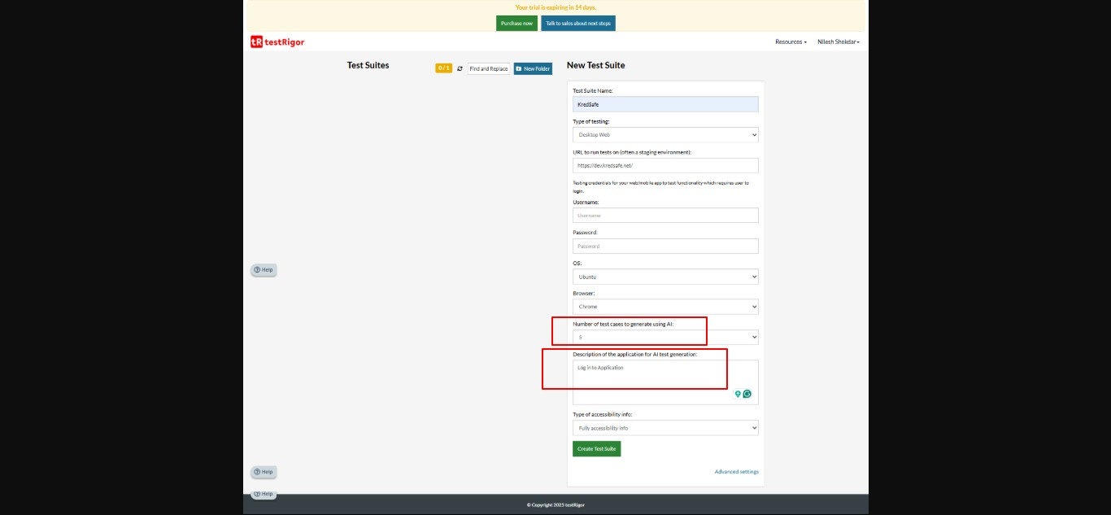

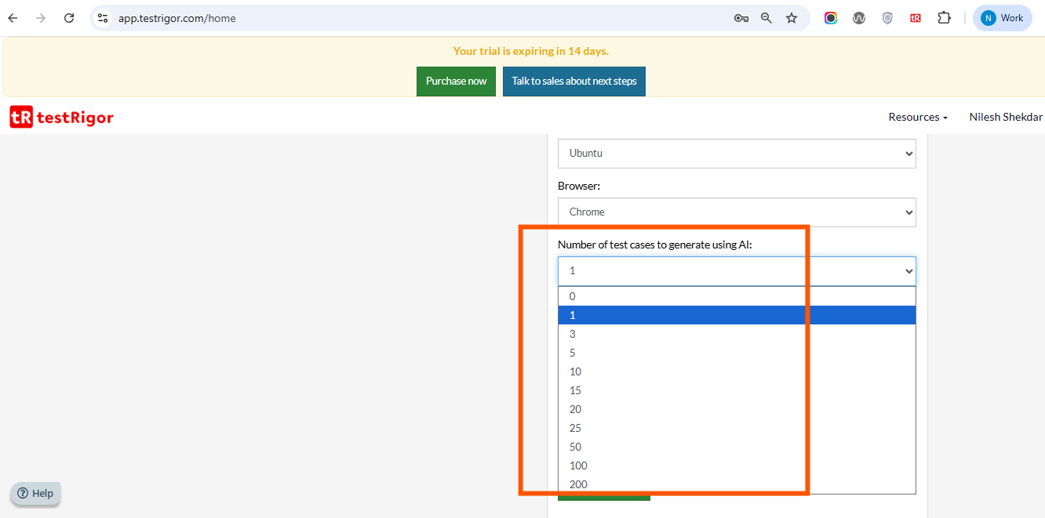

**Click on create Test Suite**

**Following 5 test cases Generated by AI for Login Functionality**

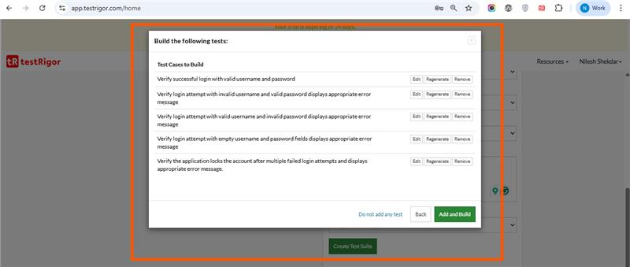

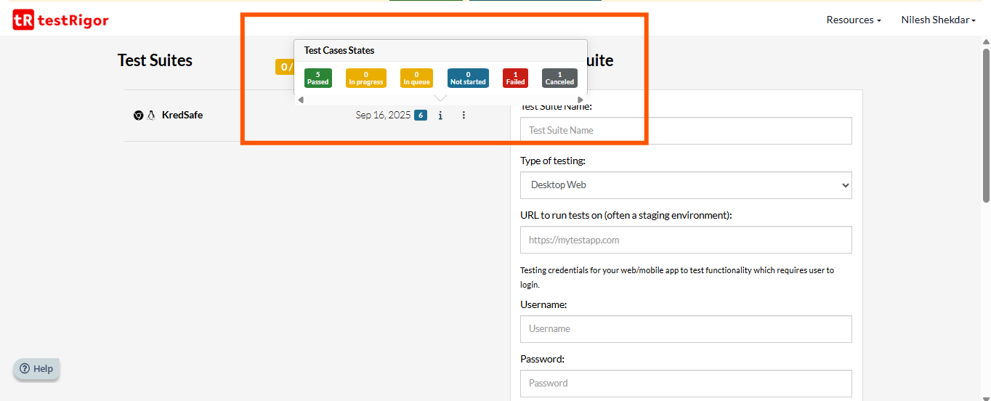

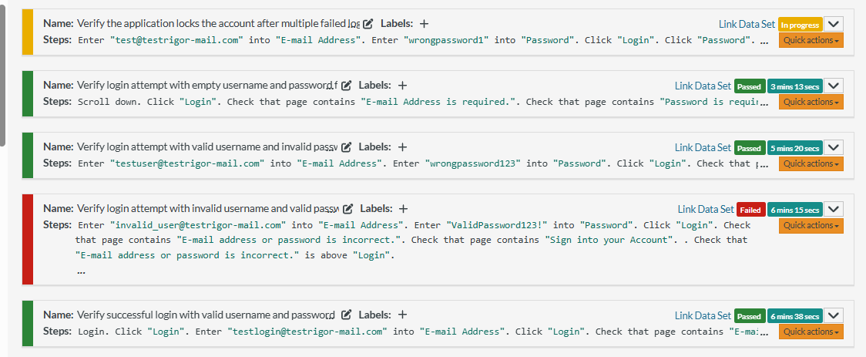

### ****AI-Test Recommended For:****

* Large and complex applications requiring broad test coverage
* Agile and DevOps teams with CI/CD pipelines needing rapid feedback
* Regression, smoke, and repetitive test scenarios
* Cross-platform applications (e.g., web, mobile, desktop)
* Teams with access to quality training data for AI learning
* Projects needing early defect prediction and test maintenance automation
* Organizations embracing low-code/no-code tools for broader team collaboration
* Applications where visual/UI consistency needs automated monitoring

### ****AI-Test Not Recommended For:****

1. Small-scale or low-complexity projects with minimal testing needs

2. Domains requiring strong contextual understanding or human reasoning (e.g., healthcare, legal edge cases)

3. Teams lacking proper infrastructure, clean data, or AI expertise

4. Projects with highly dynamic, unpredictable UI elements not suited for current AI tools

5. Testing scenarios requiring strict traceability, interpretability, or regulatory compliance

6. Organizations with tight budgets or resistance to adopting new tools and workflows

### **Conclusion for AI Test Rigor Test Cases-**

Generative AI in software testing can significantly enhance efficiency, speed, and coverage—especially in modern, agile development environments. While it reduces manual effort and improves test scalability, it’s most effective when combined with quality data and well-defined testing goals. However, it may not be ideal for all projects, particularly those with limited scope or needing deep human judgment.

## **TestTrigger CI/CD**-

**TestTrigger** is a **low-code, AI-powered end-to-end test automation platform** designed to make it easy for QA engineers and developers to create, run, and manage automated tests without needing to write complex code.

TestTrigger integrates with CI/CD pipelines to automatically trigger tests after code changes, ensuring faster releases and higher quality.

* **CI (Continuous Integration)**: Automatically integrates code changes into a shared repository and runs tests to catch bugs early.
* **CD (Continuous Delivery/Deployment)**: Automatically deploys the tested code to staging or production environments.

TestTrigger can be integrated into CI/CD tools like **GitHub Actions, GitLab CI, Jenkins, Azure DevOps, CircleCI**, etc.

## Advantages of Using TestTrigger CI/CD

| **Advantage** | **Description** |
| --- | --- |
| **Low-code Testing** | Enables writing test cases in plain English, reducing the need for coding. |
| **Fast Test Creation** | AI-assisted creation of test cases makes test setup quick. |
| **Supports Many Platforms** | Works with web, mobile, and desktop applications. |
| **Easy Integration** | Easily integrates with most popular CI/CD tools. |
| **Catches Bugs Early** | Automatically runs tests on every pull request or commit. |
| **Test Reusability** | Reuse tests across builds, reducing duplication. |
| **Faster Feedback Loop** | Developers get immediate feedback on changes. |

## Disadvantages of TestTrigger CI/CD-

| **Disadvantage** | **Description** |
| --- | --- |
| **Cost** | Not open-source. Pricing can be expensive for startups or small teams. |
| **Limited Customization** | Low-code approach may not support all complex test scenarios. |
| **Learning Curve** | While easier than code-based tools, still requires understanding of test logic. |
| **Vendor Lock-in** | Heavily relies on TestTrigger’s ecosystem. Switching later may require rewriting tests. |
| **Latency in Cloud Execution** | Cloud-based tests might be slower than local runs in some cases. |

Steps to Create a CI/CD Pipeline with TestTrigger-

### ****Step 1: Prepare Your Application for CI/CD****

* Ensure your app code is in a version control system like **GitHub, GitLab**, or **Bitbucket**.
* Your code should be structured to support automated builds and tests.

### ****Step 2: Sign Up & Configure TestTrigger****

* Go to TestTrigger and **create an account**.
* Create a **new project** for your application.
* Connect your app’s **test environment** (URL, mobile emulator, etc.)
* Set up **test scripts** in TestTrigger using plain English instructions.

### ****Step 3: Write or Generate Test Cases****

* Use TestTrigger’s AI assistant or manually write test cases like:
* go to "https://myapp.com"
* click "Login"
* type "test@example.com" into "email"
* type "password123" into "password"
* click "Submit"
* verify "Welcome back" is visible
* Organize tests into **test suites** (e.g., login tests, checkout tests).

### ****Step 4: Integrate TestTrigger with Your CI/CD Tool****

Here’s how it works with **GitHub Actions** (similar steps for GitLab, Jenkins, etc.):

Github URL

https://github.com/nilesh1710/TestRigor/

**GitHub Actions example:**

1. Create a .github/workflows/testtrigger.yml file:
2. name: Run testRigor Tests
3. on:
4. push:
5. branches: [ main ]
6. pull_request:
7. branches: [ main ]
8. jobs:
9. test:
10. runs-on: ubuntu-latest
11. steps:
12. name: Checkout code
13. uses: actions/checkout@v3
14. - name: Run testRigor tests
15. uses: testRigor/actions@v1
16. with:
17. test_suite_id: ${{ secrets.TESTRIGOR_SUITE_ID }}
18. api_token: ${{ secrets.TESTRIGOR_API_TOKEN }}

**Set Secrets** in GitHub:

* + TESTTRIGGER_API_KEY – your API key from TestTrigger

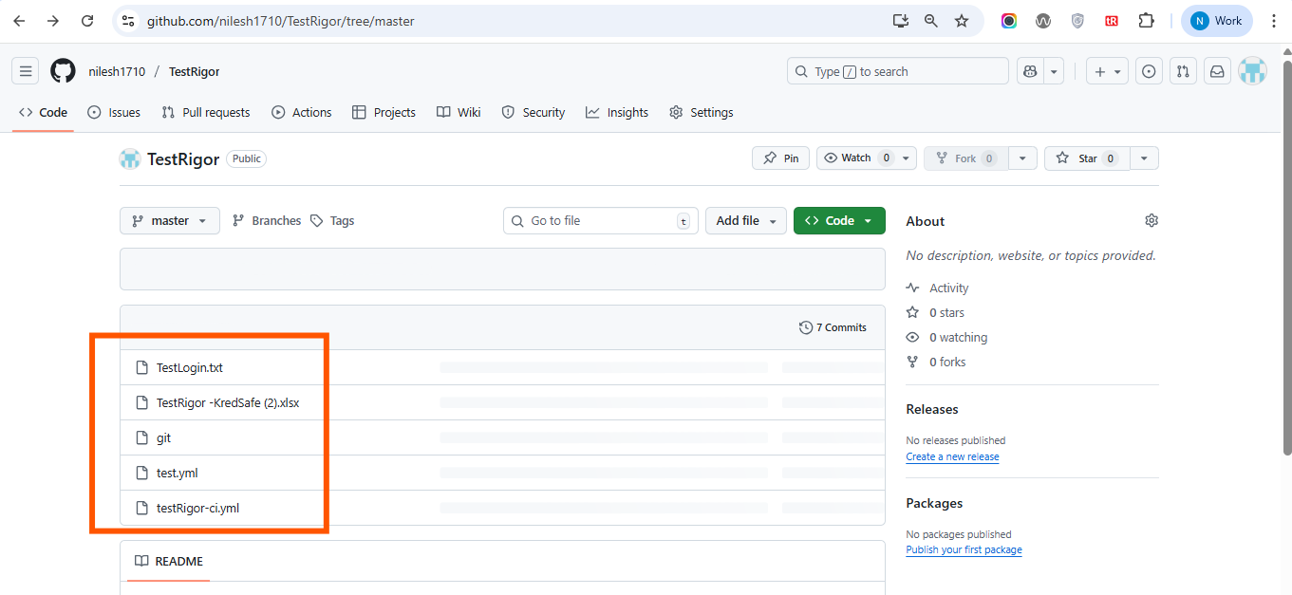

Step to push code to Github-

## 1. Create a New GitHub Repository

<https://github.com/nilesh1710/TestRigor>

## 2. Create a Local Project Folder

On your computer:

1. Open **File Explorer**.
2. Go to your Desktop.
3. Create a new folder called TestRigorTest.

Path C:\Users\Admin\Desktop\TestRigorTest

Inside this folder, create a text file (for example):

testtrigger_ci_cd.txt

create folder .github/workflow/cicd.yml

cicd.yml

name: testRigor CI

on:

  push:

    branches:

      - master

  workflow_dispatch:

jobs:

  run-tests:

    runs-on: ubuntu-latest

    steps:

      - name: Checkout code

        uses: actions/checkout@v3

          - name: Run testRigor tests

        env:

          TESTRIGOR_API_KEY: ${{ secrets.xxxxMXPI }}

        run: |

          curl -X POST "https://api.testrigor.com/v1/runs" \

            -H "Authorization: Bearer $TESTRIGOR_API_KEY" \

            -H "Content-Type: application/json" \

            -d '{"testSuiteId": "iQXqgXmNSNrigj8HX"}'

Paste your TestRigor test case or CI/CD configuration into it.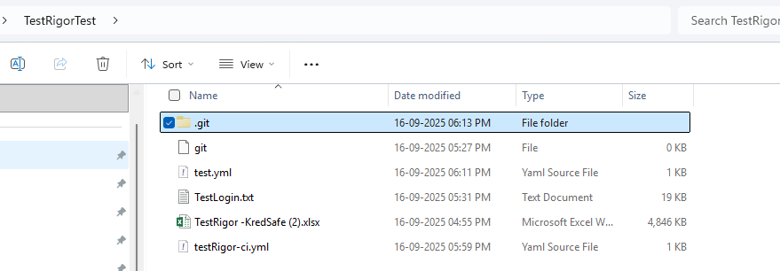

## 3. Open Command Prompt (CMD) or Git Bash

Use **CMD** or **Git Bash**, and navigate to your folder:

cd C:\Users\Admin\Desktop\TestRigorTest

## 4. Initialize Git Repository

This turns the folder into a **Git project**:

git init

Output:

Initialized empty Git repository in C:/Users/Admin/Desktop/TestRigorTest/.git/

## 5. Connect to GitHub Repository (Remote)

Link your local project to your GitHub repository:

git remote add origin https://github.com/nilesh1710/TestRigor

This connects your local folder to the **remote repo** on GitHub.

## 6. Stage All Files for Commit

This tells Git which files to include in the next commit:

git add .

means "add all files in this folder".

## 7. Commit the Files

This saves your changes in Git:

git commit -m "Added initial test Rigor test cases"

The -m flag lets you add a commit message describing the change.

## 8. Push Code to GitHub

Send your local commits to GitHub:

git push -u origin master

or git push --set-upstream origin master

Explanation:

* origin is the remote repository on GitHub.
* master is the name of your main branch (you can also use main if that’s your default).
* -u sets the upstream so you can just use git push next time.

After this, future updates can be pushed using:

git push

## Final Result

You’ve now:

* Created a local Git project
* Connected it to GitHub
* Added a text file
* Committed the file
* Pushed it to the GitHub repository

File should now be visible at:  
<https://github.com/nilesh1710/TestRigor>

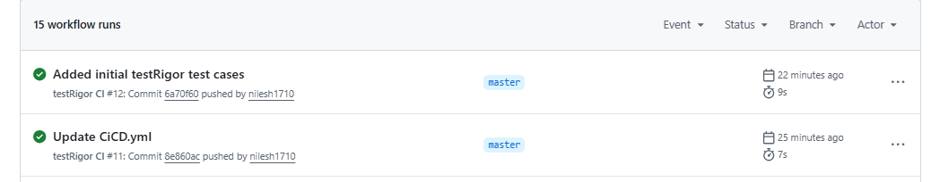

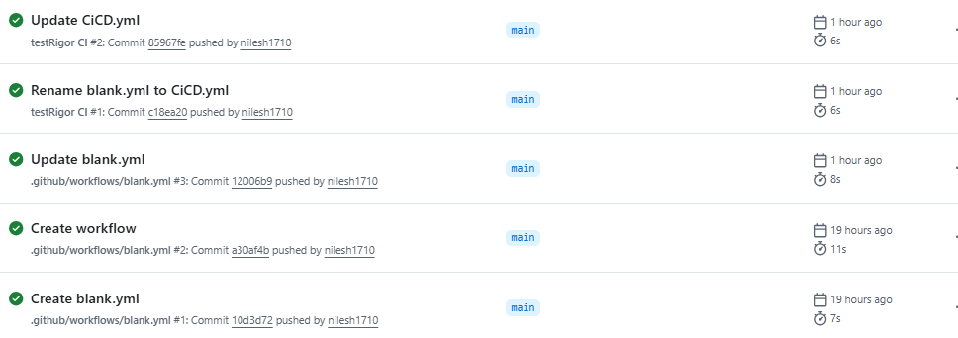

File should now be visible at:  
<https://github.com/nilesh1710/TestRigor>

### **Recommended for:**

* **QA teams using CI/CD** – because it enables automated testing with every code change.
* **Agile/DevOps teams** – because it supports fast feedback, continuous integration, and delivery.
* **Teams using TestRigor** – because it integrates easily with GitHub for managing and triggering tests.
* **Collaborative development environments** – because Git tracks changes and supports team collaboration.

### **Not recommended for:**

* **Non-technical users unfamiliar with Git** – because setting up Git and CI/CD requires command-line usage and some technical knowledge.
* **Manual, short-term testing projects** – because setting up GitHub and CI/CD is unnecessary overhead for small or one-time efforts.
* **Projects without CI/CD pipelines** – because TestRigor CI/CD integration adds no value without automated workflows.
* **Environments with strict data policies** – because pushing code/tests to GitHub may violate internal or legal compliance requirements.

## **Conclusion-**

Using Git and GitHub for managing your **TestRigor CI/CD test automation project** is a professional and scalable approach. It allows you to:

* Version control your test cases and configuration
* Collaborate with others
* Automate testing and deployment via CI/CD pipelines
* Keep your test infrastructure centralized and secure

By pushing your local code to a GitHub repository, you’ve set the foundation for continuous testing and delivery

Advantage of TestRigor-

1. **No-code test writing in plain English**  
   Write tests in human-readable language — no programming required.
2. **AI-based element detection**  
   Automatically detects UI elements using semantic understanding instead of brittle selectors.
3. **Efficient timeout handling**  
   Built-in smart waits for elements and actions to complete, reducing false failures.
4. **Extremely low maintenance**  
   Tests rarely break even if the UI structure changes — maintenance effort is significantly reduced.
5. **Cross-browser and mobile device support**  
   Test on multiple browsers (Chrome, Firefox, Safari, Edge) and real mobile devices.
6. **All-in-one platform**  
   Supports web, mobile (native/hybrid), desktop, API, email, SMS, 2FA, etc. — unified under one platform.
7. **Reusable steps and data-driven testing**  
   Use shared rules and variables across tests, and run the same test with different input data.
8. **Built for non-technical users**  
   Ideal for manual testers, product managers, QA analysts, and business users.
9. **Test Case Recorder (Chrome Extension)**  
   Record browser actions and convert them into plain-English test scripts automatically.
10. **No need for XPath, CSS selectors, or IDs**  
    Eliminates dependency on DOM-specific identifiers, reducing test flakiness and fragility.
11. **Stable despite UI changes**  
    You don’t need to update tests unless visible, user-facing text changes — ideal for agile UI changes.
12. **CI/CD and DevOps integration**  
    Seamlessly integrates with Jenkins, GitHub Actions, CircleCI, etc., for automated test execution in pipelines.
13. **Supports parallel and scheduled execution**  
    Run tests in parallel or on a defined schedule across multiple environments.
14. **Detailed reporting and diagnostics**  
    Get step-by-step logs, screenshots, and video (if enabled) to debug failed tests easily.
15. **Cloud-based with no local setup**  
    Fully SaaS — tests are run in the cloud, reducing infrastructure and setup overhead.

**Limitation Of TestRigors-**

1. **Not open-source**  
   Unlike Selenium or Playwright, testRigor is a proprietary, closed platform.
2. **Limited flexibility for custom logic or scripting**  
   It lacks low-level scripting capabilities, making it harder to implement complex custom flows.
3. **Not ideal for developers or code-heavy QA teams**  
   Teams preferring code-based frameworks may find it limiting.
4. **Tests may require updates for frequently changing test data or files**  
   Dynamic input like file uploads may not auto-update and can require manual maintenance.
5. **Heavily dependent on visible UI text for element identification**  
   If visible text changes, tests may break — not suitable for UI with minimal or dynamic text.
6. **Limited control over browser internals**  
   Compared to tools like Playwright, testRigor lacks access to low-level browser features (e.g., network mocking, performance tracing).
7. **Cost may be high for large teams**  
   Licensing is usage-based and may become expensive at scale, especially for parallel tests and enterprise features.
8. **No local test execution**  
   All tests run in the cloud — unlike Selenium/Playwright, there’s no ability to run tests fully offline or on-prem.
9. **Not suitable for offline or air-gapped environments**  
   Requires internet access and cannot be hosted internally without enterprise-level customization.
10. **Limited mobile testing experience**

Small screen real estate restricts ease of test writing.

Handling complex mobile UIs (e.g., tables, nested components) is still maturing.

1. **New mobile test cases require new rules and data setups**  
   Mobile scenarios often need extra effort to define reusable rules and variables.
2. **Learning curve in writing complex scenarios using natural language**  
   While easy for basic tests, using plain English effectively in advanced cases can be unintuitive.
3. **Not ideal for complex logic or calculation-heavy flows**  
   Validating conditional logic, loops, and mathematical validations is limited.
4. **Manual effort for dynamic file uploads**  
   Uploads often require hardcoded file paths or manual configuration, reducing automation in dynamic test scenarios.
5. **Test organization can be challenging at scale**  
   Managing hundreds or thousands of test cases across teams requires discipline with naming, tagging, and reuse.
6. **iOS device testing does not support remote file uploads**  
   Due to iOS system restrictions and limitations in remote device access, testRigor currently does not support file upload scenarios on iOS devices.
7. • **File uploads are saved to S3, which may raise security or compliance concerns**  
   Uploaded files are stored temporarily in AWS S3 buckets by testRigor. For some organizations, especially in regulated industries, this may conflict with internal security or data privacy policies.

Conclusion-

**TestRigor** is a **powerful no-code test automation platform** built primarily for teams seeking to:

After a detailed evaluation of **testRigor**, we found it to be a strong candidate for teams seeking a **low-code/no-code test automation platform** with high stability and ease of use. Its plain-English scripting, AI-based element detection, and cross-platform support make it especially valuable for non-technical users and fast-moving QA teams.

However, testRigor does have limitations, particularly around **custom scripting, offline usage, and complex file handling**. It may not be suitable for all use cases, especially in **security-sensitive environments** or teams that require **deep browser control** and **full flexibility**.

It shines in **plain-English test writing**, **low-maintenance test stability**, and **broad platform coverage**, making it ideal for:

* QA Analysts
* Manual Testers
* Product Managers
* Business Analysts
* Agile teams adopting shift-left testing
* Organizations with limited automation engineering capacity

We recommend **using testRigor** for:

* Smoke and regression testing
* Manual-to-automated test transitions
* Teams with limited coding experience
* Reduce test creation and maintenance time
* Empower non-technical users to write and manage tests
* Scale automated testing across web, mobile, desktop, and APIs without deep programming knowledge

We **do not recommend** it for:

* Advanced technical workflows requiring low-level scripting
* Highly regulated industries with strict data handling requirements
* Require full control over browser internals or system-level hooks
* Operate in air-gapped, offline, or highly restricted environments
* Rely heavily on dynamic file uploads, complex logic flows, or scripting flexibility
* Need tight control over test infrastructure or custom integrations beyond what testRigor provides
* **Not ideal for mobile testing due to limited screen space and complex UI handling.**

Best Use cases-

* End-to-end regression and smoke testing
* Cross-browser and mobile validation
* Data-driven test scenarios with reusable flows
* CI/CD pipelines for non-dev teams
* Testing by business stakeholders without technical support